Abstract

This documentation contains the product planning, product designing, project management and product development phases of the module.

Documentation on development of e-commerce Website

Project Management

Name: Bibhas Bahadur Shrestha

Student ID: c7190018

Level: 5

Section: B

Team Name: Epsilon Web Developers

Table of Contents

1. Product Planning 1

1.1 Team Contract 1

1.2 Project Charter 5

1.2.1 Project Charter Version 1 5

1.2.2 Project Charter Version 2 8

1.3 Belbin’s Analysis 11

1.3.1 Team Belbin’s Analysis 11

1.3.2 Individual Belbin’s Analysis 15

1.4 Skill Audit 16

1.4.1 Team Skill Audit 16

1.4.2 Individual Skill Audit 17

2. Project Management 17

2.1 Microsoft Project 17

2.1.1 Task Sheet 17

2.1.2 Gantt Chart 21

2.1.3 Resource Sheet 22

2.1.4 Calendar 23

2.1.5 Timeline 25

2.2 Communication and Collaboration Tools Used 26

2.2.1 Trello 26

2.2.2 Hangouts 27

2.2.3 Google Drive 28

3. Product Designing 29

3.1 Entity Relationship Diagram 29

3.1.1 Extended Entity Relationship Diagram 30

3.1.2 Logical Design 30

3.1.3 Composite ERD 31

3.2 Use Case Diagram 32

3.2.1 Overview Use Case Diagram 32

3.2.2 Customer User Case Diagram 33

3.2.3 Trader Use Case Diagram 34

3.2.4 Management Use Case Diagram 34

3.2.5 User Use Case Diagram 35

3.3 Requirement Catalogue 35

3.3.1 Functional Requirements 35

3.3.2 Non-Functional Requirements 39

3.4 Team Logo 40

3.4.1 Website Logo 41

3.4.2 Website Wireframe 42

4. Product Development 49

4.1 Database Tables in Oracle 49

4.1.1 User 49

4.1.2 Shop 50

4.1.3 Product Types 50

4.1.4 Product 51

4.1.5 Product Offer 51

4.1.6 Cart 52

4.1.7 Product Order 52

4.1.8 Order Detail 53

4.1.9 Payment 53

4.1.10 Collection Slot 54

4.2 Website Home Page 54

# 1. Product Planning

## 1.1 Team Contract

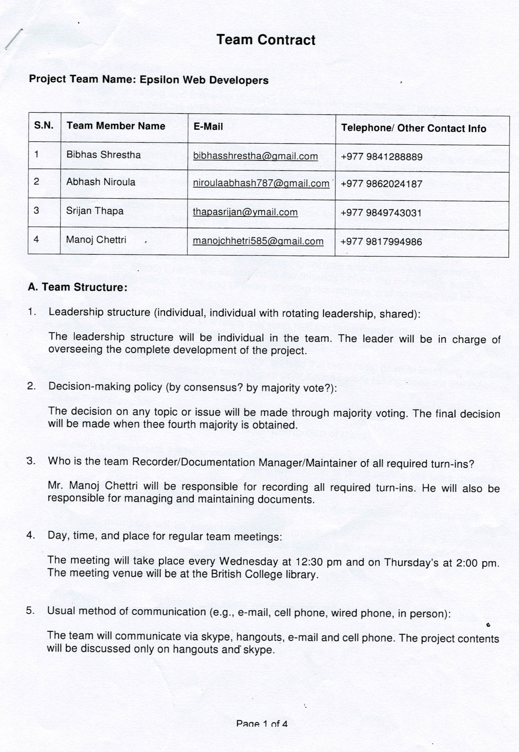

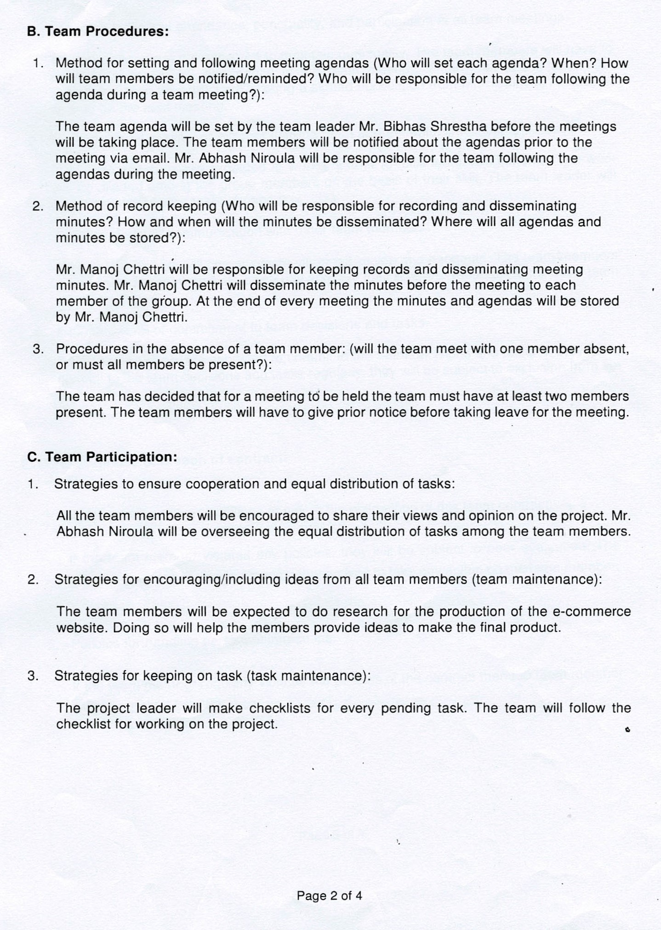

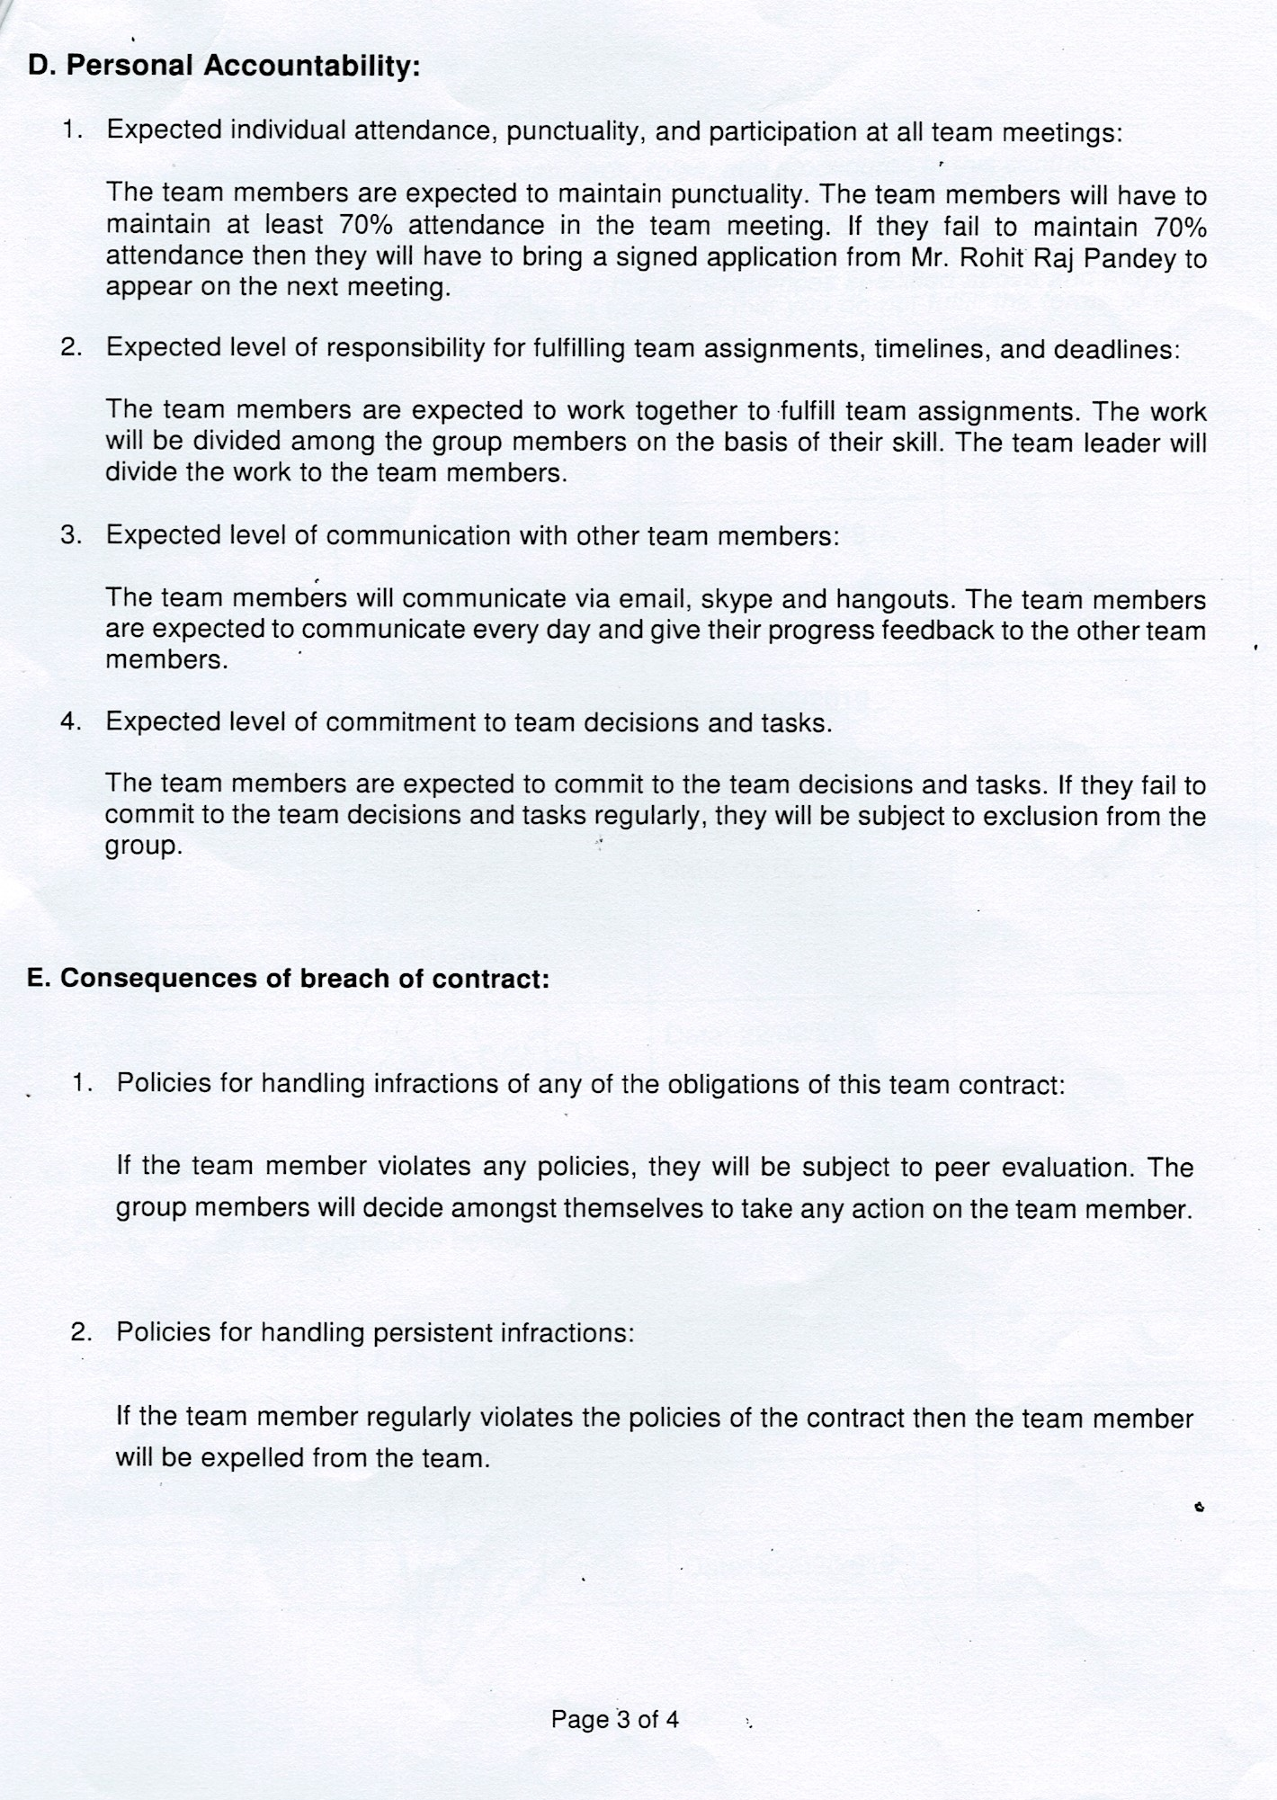

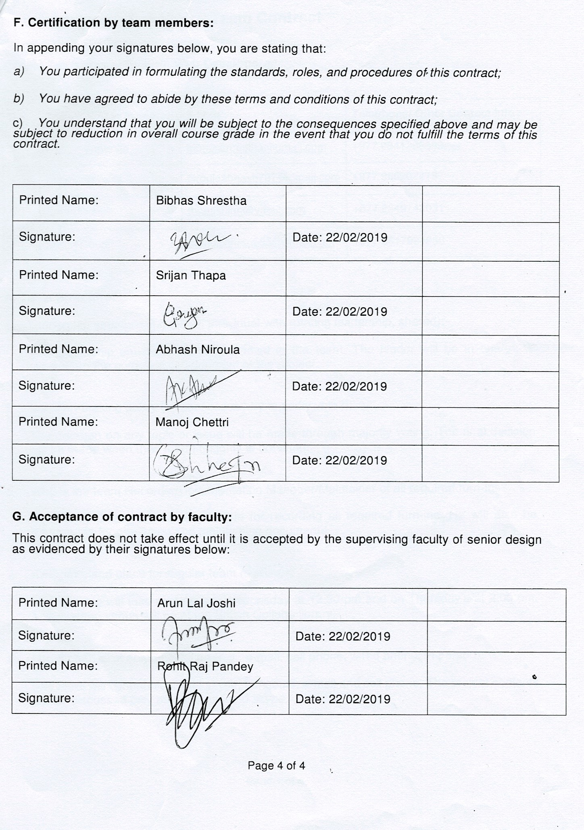

## 1.2 Project Charter

### 1.2.1 Project Charter Version 1

|  |
| --- |
| Project Title: Developing an e-commerce website for traders in Cleckhuddersfax. |

Version Control

|  |  |  |
| --- | --- | --- |
| Version | Date | Summary of changes |
| 1.0.0 | 22/02/2019 | No changes made. |
|  |  |  |
|  |  |  |

Project Justification

|  |
| --- |
| The project aims at creating an e-commerce website for the traders in Cleckhuddersfax. The traders in the area have jointly agreed to sell their products through the e-commerce website. Through the interface, the traders will be able to sell their products direct to consumers.    The system will allow local residents who cannot shop locally during normal opening hours to purchase goods from their local traders. The traders specialize in locally sourced high-quality goods, which are growing in popularity but cannot be purchased through local supermarkets. The development of the e-commerce website will help the traders to sell their products in the competitive retail market without losing out their revenue to the national chains.  The e-commerce platform will mainly focus on ease of access to the customers. The major target will be to provide a convenient user experience. |

Project Scope

|  |
| --- |
| **Objectives**   * Maintain or increase the shop turnover within 12 months of launching the website. * Attract new customers that would otherwise not be able to shop with the traders. * Be usable by traders within a normal and suitable working time. * Create a responsive interface so that it can be accessed across multiple devices. |
| **High level requirements:**  **Customer Interface**   1. Customers should be able to navigate to products by shop or by product type. 2. Customers should be provided with a single basket that holds goods that spans all traders and requires a single payment. 3. Customers should be required to register before they can place an order and be logged in to access the basket. 4. Customers should be able to review and update their account details.   **Trader Interface**   1. Traders should be able to manage their products and information on their shops via a web interface. 2. Traders should be able to add, delete and update their products. 3. Traders will login to the database on a daily basis to view reports on orders and stock levels. 4. Traders should have a trader login that allows them access to their details only.   **Management Interface**   1. A management dashboard to monitor trader and customer activity. 2. The management dashboard will give the traders access to a range of daily and periodic reports. 3. The management will provide traders with a weekly finance report which will identify payments to be made to them resulting from the previous 7 days orders. 4. The management will provide monthly report on product sales to the traders. |
| **Major deliverables**   1. E-Commerce website with customer and trader interface. 2. Database linked to e-commerce site with management interface. 3. Admin facility for traders to add, update and delete their products. 4. Add to cart functionality with billing system with PayPal Integration. |

Duration

|  |  |
| --- | --- |
| Name | Date |
| Project start date | 5/02/2019 |
| Work in Progress submission | 28/03/2019 |
| Final Project presentation | 06/05/2019 |
| Team Portfolio and Individual Report submission | 10/05/2019 |

Assumptions

|  |
| --- |
| * The platform would be developed using PHP and Laravel Framework. * The trader would be able to use the platform only after receiving verification from the management. * The management would be able to block the trader from using the platform if the trader violates the terms of agreement. * Customers would be required to login to the platform to purchase items. |

Roles and Responsibilities

|  |  |
| --- | --- |
| Name | Role |
| Bibhas Bahadur Shrestha | Resource Investigator, Co-ordinator, Completer Finisher |
| Abhash Niroula | Specialist, Shaper |
| Srijan Thapa | Monitor Evaluator, Team-worker |
| Manoj Chhetri | Implementer |

Communication and Collaboration Tools

|  |
| --- |
| **Hangouts:**  Hangouts will be used as the official source for communication. Team announcements and reminders will be given on Hangouts. It will also be used for conference calls and video chats.  **Trello:**  Trello will be used to plan the project, to prioritize important aspects of the project and to allocate tasks among the team members.  **Google Drive:**  Google Drive will be used to share the project files among the team members. The team members will upload their work on the shared google drive folder to keep the team members in sync with their progress. |

### 1.2.2 Project Charter Version 2

|  |
| --- |
| Project Title: Developing an e-commerce website for traders in Cleckhuddersfax. |

Version Control

|  |  |  |
| --- | --- | --- |
| Version | Date | Summary of changes |
| 2.0.0 | 22/02/2019 | Belbin’s Analysis, Skill Audit, EERD, Use Case Diagram and Wireframe Design were all completed. |
|  |  |  |
|  |  |  |

Project Justification

|  |
| --- |
| The project aims at creating an e-commerce website for the traders in Cleckhuddersfax. The traders in the area have jointly agreed to sell their products through the e-commerce website. Through the interface, the traders will be able to sell their products direct to consumers.    The system will allow local residents who cannot shop locally during normal opening hours to purchase goods from their local traders. The traders specialize in locally sourced high-quality goods, which are growing in popularity but cannot be purchased through local supermarkets. The development of the e-commerce website will help the traders to sell their products in the competitive retail market without losing out their revenue to the national chains.  The e-commerce platform will mainly focus on ease of access to the customers. The major target will be to provide a convenient user experience. |

Project Scope

|  |
| --- |
| **Objectives**   * Maintain or increase the shop turnover within 12 months of launching the website. * Attract new customers that would otherwise not be able to shop with the traders. * Be usable by traders within a normal and suitable working time. * Create a responsive interface so that it can be accessed across multiple devices. |
| **High level requirements:**  **Customer Interface**   1. Customers should be able to navigate to products by shop or by product type. 2. Customers should be provided with a single basket that holds goods that spans all traders and requires a single payment. 3. Customers should be required to register before they can place an order and be logged in to access the basket. 4. Customers should be able to review and update their account details.   **Trader Interface**   1. Traders should be able to manage their products and information on their shops via a web interface. 2. Traders should be able to add, delete and update their products. 3. Traders will login to the database on a daily basis to view reports on orders and stock levels. 4. Traders should have a trader login that allows them access to their details only.   **Management Interface**   1. A management dashboard to monitor trader and customer activity. 2. The management dashboard will give the traders access to a range of daily and periodic reports. 3. The management will provide traders with a weekly finance report which will identify payments to be made to them resulting from the previous 7 days orders. 4. The management will provide monthly report on product sales to the traders. |
| **Major deliverables**   1. E-Commerce website with customer and trader interface. 2. Database linked to e-commerce site with management interface. 3. Admin facility for traders to add, update and delete their products. 4. Add to cart functionality with billing system with PayPal Integration. |

Duration

|  |  |
| --- | --- |
| Name | Date |
| Project start date | 5/02/2019 |
| Work in Progress submission | 28/03/2019 |
| Final Project presentation | 06/05/2019 |
| Team Portfolio and Individual Report submission | 10/05/2019 |

Assumptions

|  |
| --- |
| * The platform would be developed using PHP and Laravel Framework. * The trader would be able to use the platform only after receiving verification from the management. * The management would be able to block the trader from using the platform if the trader violates the terms of agreement. * Customers would be required to login to the platform to purchase items. |

Roles and Responsibilities

|  |  |
| --- | --- |
| Name | Role |
| Bibhas Bahadur Shrestha | Resource Investigator, Co-ordinator, Completer Finisher |
| Abhash Niroula | Specialist, Shaper |
| Srijan Thapa | Monitor Evaluator, Team-worker |
| Manoj Chhetri | Implementer |

Communication and Collaboration Tools

|  |
| --- |
| **Hangouts:**  Hangouts will be used as the official source for communication. Team announcements and reminders will be given on Hangouts. It will also be used for conference calls and video chats.  **Trello:**  Trello will be used to plan the project, to prioritize important aspects of the project and to allocate tasks among the team members.  **Google Drive:**  Google Drive will be used to share the project files among the team members. The team members will upload their work on the shared google drive folder to keep the team members in sync with their progress. |

## 1.3 Belbin’s Analysis

### 1.3.1 Team Belbin’s Analysis

|  |  |  |
| --- | --- | --- |
| Version:1.1 **Belbin’s Analysis** Date reviewed: 2/3/2019 | | |
| Primary role | Bibhas Shrestha | Co-ordinator |
| Srijan Thapa | Specialist |
| Abhash Niroula | Team worker |
| Manoj Chhetri | Implementer |
|  |  |
| Secondary role | Bibhas Shrestha | Complete Finisher |
| Srijan Thapa | Shaper |
| Abhash Niroula | Monitor Evaluator |
| Manoj Chhetri | Plant |
|  |  |
| Least likely role | Bibhas Shrestha | Plant |
| Srijan Thapa | Co-ordinator |
| Abhash Niroula | Resource Investigator |
| Manoj Chhetri | Complete Finisher |
|  |  |
| Do you think the descriptions of these roles are an accurate description of your behaviour in teams? How do you see yourself differently? | Bibhas Shrestha | I think the description of these roles are accurate description of my behaviour. I think being the team leader gives me certain responsibilities and co-ordinator fits the role of a leader. |
| Srijan Thapa | Yes, the description of the role is an accurate description of my behaviour in the team because I can bring in-depth knowledge on key areas to the team. |
| Abhash Niroula | I think the descriptions of these roles are fairly accurate description of my behaviour. The description of the role Team worker suits my personality as I am more type of diplomatic person who believes in teamwork. |
| Manoj Chhetri | Yes, I think the description of the role is an accurate description of my behaviour in the team as I am proficient in planning a workable strategy and carrying it out as efficiently as possible. |
|  |  |
| Are there roles identified by Belbin that you might like to develop in yourself more? Which ones and why? | Bibhas Shrestha | Complete Finisher is the role I would like to develop in myself because the role would allow me to polish and scrutinise the team’s work for errors which would allow me to subject the work to the highest standard. |
| Srijan Thapa | Shaper is the role I would like to develop myself in because I would like to improve my ability to ensure that the team keeps moving and does not lose focus or momentum. |
| Abhash Niroula | Specialist is the role identified by Belbin that I would like to develop in myself. I think this is a challenging role and I want to be more dedicated towards particular topic to gain depth knowledge about it. |
| Manoj Chhetri | I would like to develop myself as the Plant because I would be able to generate creative ideas and solve difficult problems. |
|  |  |
| What possible situations in the coming months can you identify where you could work on developing these skills? | Bibhas Shrestha | In the coming months I would be able to develop my skill as co-ordinator. I will be responsible to delegate work appropriately in the team. |
| Srijan Thapa | In the upcoming months our team may struggle in key areas during the project and I think I will be able to help them during this situation to fulfil my role as the specialist. |
| Abhash Niroula | There may arise situation like communication issues between team members where I could really put my skills on test. As a team worker I would co-ordinate with my team members properly and understand their problems and try to resolve it in a way what’s good for the team. I will make sure of one thing in my mind that I must give adequate time and space for my team members. |
| Manoj Chhetri | In the upcoming months I think I could improve my creativity and problem-solving skills for the betterment of the project. |
|  |  |
| Considering your team working, how do you think you could improve your effectiveness in group work and in contributing to the success of teams that you work in? | Bibhas Shrestha | I think I could improve my punctuality to bring more effectiveness to the group work and contribute to the success of the team. |
| Srijan Thapa | I think I could improve my communication skills to contribute to the group. |
| Abhash Niroula | I think in order to improve effectiveness in group work I would have to be visionary about the consequences that might occur while doing the project. I should be able to judge what is wrong and what is right for the team. And to contribute for the team success I should be a factor for my team motivation by being strict about the goals, rules and regulations of our team. |
| Manoj Chhetri | I think I could improve my effectiveness in the group work and contribute to its success by managing my time properly. |
|  |  |
| Are the results of this inventory consistent with how you worked in the Foundation Project in your small groups for discussions and presentations? | Bibhas Shrestha | The result of this inventory is not consistent with the Foundation Project as earlier we did not divide the roles among ourselves and we did not plan the final outcome of our project. |
| Srijan Thapa | I think the results of this inventory is fairly consistent with the previous projects. |
| Abhash Niroula | The result of this inventory is not consistent with the foundation project we worked earlier. Previously, the process involved in achieving the result was not planned in an organized way but this time the process involved in achieving the results are different than the previous one as it is done in more organized way. This time we considered 5 main project management phases which was not done previously which made it easy to keep track of the project. |
| Manoj Chhetri | I think the results of this inventory is not consistent with the previous projects that I have been a part of. |
|  |  |
| How well did you contribute to group presentations? | Bibhas Shrestha | My contribution to group projects has always been more than my group members. I work extensively to ensure the group project is done perfectly. |
| Srijan Thapa | I contribute to the best of my ability in group projects. I always try to put maximum effort to the group presentations. |
| Abhash Niroula | Working with group was a challenging task to achieve. I was fairly good in contributing to the group presentations. I was positive about my role in the group. The task which was assigned to me by group leader was completed well on time. I think I was supportive enough to my group members for presentation. The most important part I think which really made to contribute to the group was learning from my mistakes and dealing with it. |
| Manoj Chhetri | I contribute moderately to the group presentations but I will gradually improve my contribution to the group. |
|  |  |
| What most contributed to the success of your group in that exercise | Bibhas Shrestha | The understanding between the group members was the key factor that contributed to the success of the group during the exercise. |
| Srijan Thapa | The proper management of time contributed to the success of the group in the exercise. |
| Abhash Niroula | Class time group discussions between group members, Supportive nature of group members, all team members understanding the goals of the group, Handling nerves during the exercise and Troubleshooting the problems in right way. |
| Manoj Chhetri | The creativity of the group members contributed to the success of the group in that exercise. |
|  |  |
| What prevented your group from doing better in the exercise? | Bibhas Shrestha | The lack of time management prevented the team from doing better. We felt that we could do the project better but were not able to because of the poor planning in finishing the task. |
| Srijan Thapa | The lack of communication between the group members prevented the group from doing better in the exercise. |
| Abhash Niroula | Poor preparation, Lack of time management, Team members not being serious about their respective roles, Absence of team members during meetings, Inadequate documentation and tracking and unequal distribution of workload within the group. |
| Manoj Chhetri | The irregularity of the group members prevented the group from doing better in the exercise. |
|  |  |

### 1.3.2 Individual Belbin’s Analysis

|  |  |  |
| --- | --- | --- |
| Version:1.1 **Belbin’s Analysis** Date reviewed: 2/3/2019 | | |
| Primary role | Bibhas Shrestha | Co-ordinator |
| Secondary role | Bibhas Shrestha | Complete Finisher |
| Least likely role | Bibhas Shrestha | Plant |
| Do you think the descriptions of these roles are an accurate description of your behaviour in teams? How do you see yourself differently? | Bibhas Shrestha | I think the description of these roles are accurate description of my behaviour. I think being the team leader gives me certain responsibilities and co-ordinator fits the role of a leader. |
| Are there roles identified by Belbin that you might like to develop in yourself more? Which ones and why? | Bibhas Shrestha | Complete Finisher is the role I would like to develop in myself because the role would allow me to polish and scrutinise the team’s work for errors which would allow me to subject the work to the highest standard. |
| What possible situations in the coming months can you identify where you could work on developing these skills? | Bibhas Shrestha | In the coming months I would be able to develop my skill as co-ordinator. I will be responsible to delegate work appropriately in the team. |
| Considering your team working, how do you think you could improve your effectiveness in group work and in contributing to the success of teams that you work in? | Bibhas Shrestha | I think I could improve my punctuality to bring more effectiveness to the group work and contribute to the success of the team. |
| Are the results of this inventory consistent with how you worked in the Foundation Project in your small groups for discussions and presentations? | Bibhas Shrestha | The result of this inventory is not consistent with the Foundation Project as earlier we did not divide the roles among ourselves and we did not plan the final outcome of our project. |
| How well did you contribute to group presentations? | Bibhas Shrestha | My contribution to group projects has always been more than my group members. I work extensively to ensure the group project is done perfectly. |
| What most contributed to the success of your group in that exercise | Bibhas Shrestha | The understanding between the group members was the key factor that contributed to the success of the group during the exercise. |
| What prevented your group from doing better in the exercise? | Bibhas Shrestha | The lack of time management prevented the team from doing better. We felt that we could do the project better but were not able to because of the poor planning in finishing the task. |

## 1.4 Skill Audit

### 1.4.1 Team Skill Audit

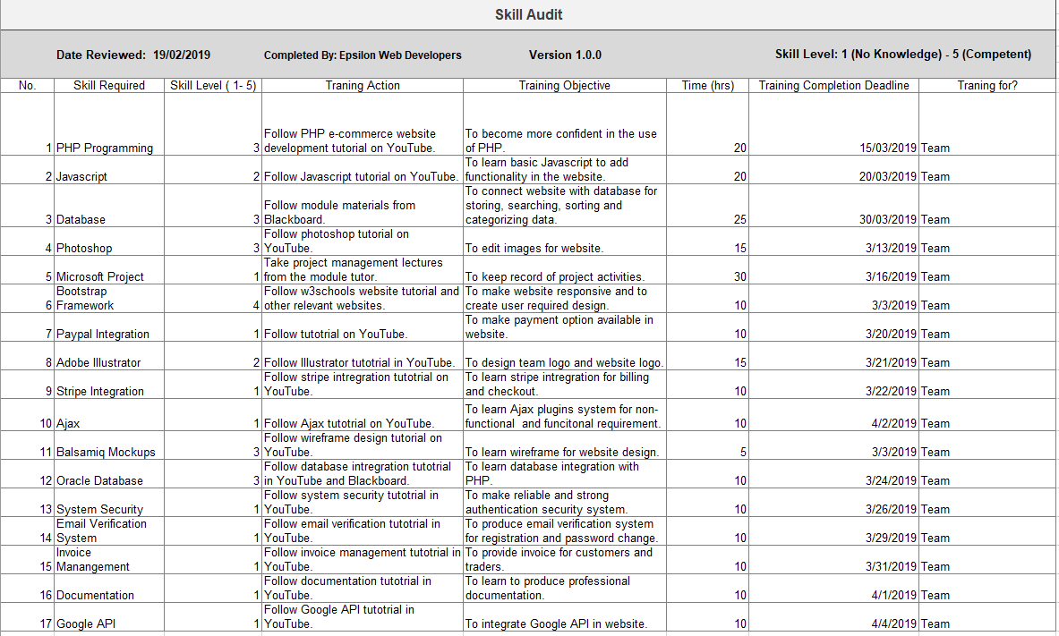

### 1.4.2 Individual Skill Audit

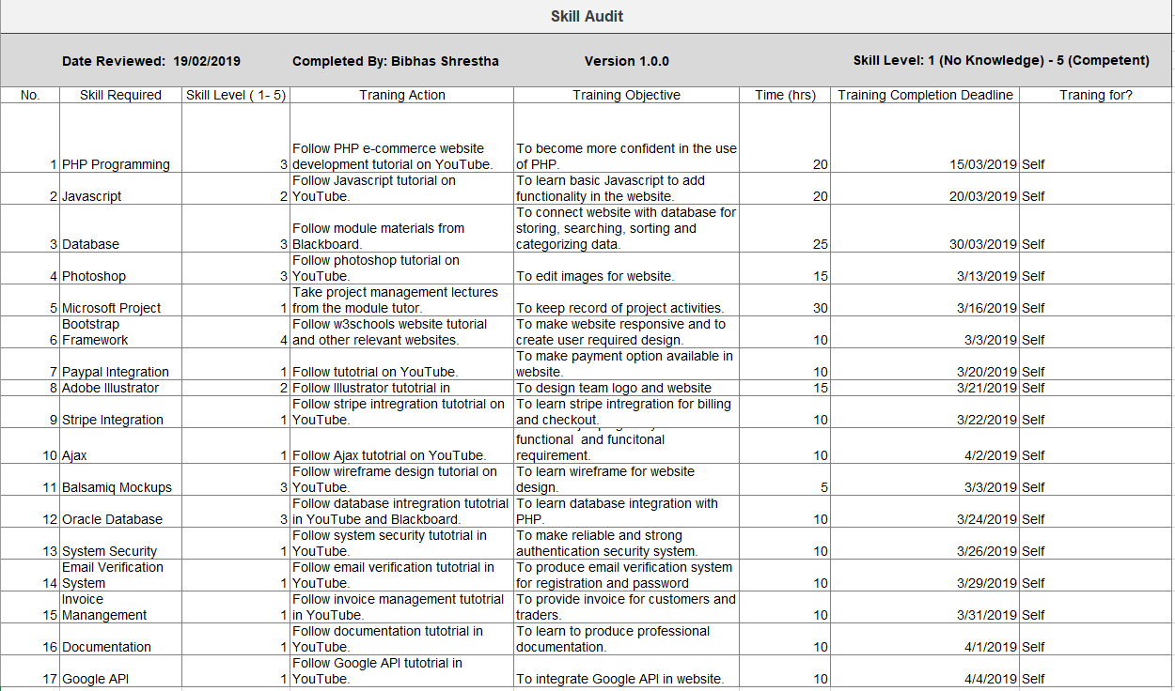

# 2. Project Management

## 2.1 Microsoft Project

### 2.1.1 Task Sheet

|  |  |  |  |  |  |  |
| --- | --- | --- | --- | --- | --- | --- |
| Task Mode | Task Name | Duration | Start | Finish | Predecessors | Resource Names |
| **Manually Scheduled** | **Epsilon Team Module** | **62 days?** | **Mon 2/11/19** | **Tue 5/7/19** |  |  |
| **Auto Scheduled** | **Meeting** | **18.38 days** | **Mon 2/11/19** | **Mon 5/6/19** |  |  |
| Manually Scheduled | Meeting 1 | 1 day | Mon 2/11/19 | Mon 2/11/19 |  | Bibhas Shrestha, Abhash Niroula, Srijan Thapa, Manoj Chhetri |
| Manually Scheduled | Meeting 2 | 1 day | Thu 2/14/19 | Thu 2/14/19 |  | Bibhas Shrestha, Abhash Niroula, Srijan Thapa, Manoj Chhetri |
| Manually Scheduled | Meeting 3 | 1 day | Mon 2/18/19 | Mon 2/18/19 |  | Bibhas Shrestha, Abhash Niroula, Srijan Thapa, Manoj Chhetri |
| Manually Scheduled | Meeting 4 | 1 day | Thu 2/21/19 | Thu 2/21/19 |  | Bibhas Shrestha, Abhash Niroula, Srijan Thapa, Manoj Chhetri |
| Manually Scheduled | Meeting 5 | 1 day | Mon 2/25/19 | Mon 2/25/19 |  | Bibhas Shrestha, Abhash Niroula, Srijan Thapa, Manoj Chhetri |
| Manually Scheduled | Meeting 6 | 1 day | Thu 2/28/19 | Thu 2/28/19 |  | Bibhas Shrestha, Abhash Niroula, Srijan Thapa, Manoj Chhetri |
| Manually Scheduled | Meeting 7 | 1.13 days | Mon 3/4/19 | Mon 3/4/19 |  | Bibhas Shrestha, Abhash Niroula, Srijan Thapa, Manoj Chhetri |
| Manually Scheduled | Meeting 8 | 1 day | Thu 3/7/19 | Thu 3/7/19 |  | Bibhas Shrestha, Abhash Niroula, Srijan Thapa, Manoj Chhetri |
| Manually Scheduled | Meeting 9 | 1 day | Mon 3/11/19 | Mon 3/11/19 |  | Bibhas Shrestha, Abhash Niroula, Srijan Thapa, Manoj Chhetri |
| Manually Scheduled | Meeting 10 | 1 day | Thu 3/14/19 | Thu 3/14/19 |  | Bibhas Shrestha, Abhash Niroula, Srijan Thapa, Manoj Chhetri |
| Manually Scheduled | Meeting 11 | 1 day | Mon 3/18/19 | Mon 3/18/19 |  | Bibhas Shrestha, Abhash Niroula, Srijan Thapa, Manoj Chhetri |
| Manually Scheduled | Meeting 12 | 1 day | Thu 3/21/19 | Thu 3/21/19 |  | Bibhas Shrestha, Abhash Niroula, Srijan Thapa, Manoj Chhetri |
| Manually Scheduled | Meeting 13 | 1 day | Mon 3/25/19 | Mon 3/25/19 |  | Bibhas Shrestha, Abhash Niroula, Srijan Thapa, Manoj Chhetri |
| Manually Scheduled | Meeting 14 | 1 day | Thu 3/28/19 | Thu 3/28/19 |  | Bibhas Shrestha, Abhash Niroula, Srijan Thapa, Manoj Chhetri |
| Manually Scheduled | Meeting 15 | 1 day | Mon 4/1/19 | Mon 4/1/19 |  | Bibhas Shrestha, Abhash Niroula, Srijan Thapa, Manoj Chhetri |
| Manually Scheduled | Meeting 16 | 1 day | Thu 4/4/19 | Thu 4/4/19 |  | Bibhas Shrestha, Abhash Niroula, Srijan Thapa, Manoj Chhetri |
| Manually Scheduled | Meeting 17 | 1 day | Mon 4/8/19 | Mon 4/8/19 |  | Bibhas Shrestha, Abhash Niroula, Srijan Thapa, Manoj Chhetri |
| Manually Scheduled | Meeting 18 | 1 day | Thu 4/11/19 | Thu 4/11/19 |  | Bibhas Shrestha, Abhash Niroula, Srijan Thapa, Manoj Chhetri |
| Manually Scheduled | Meeting 19 | 1 day | Mon 4/15/19 | Mon 4/15/19 |  | Bibhas Shrestha, Abhash Niroula, Srijan Thapa, Manoj Chhetri |
| Manually Scheduled | Meeting 20 | 1 day | Thu 4/18/19 | Thu 4/18/19 |  | Bibhas Shrestha, Abhash Niroula, Srijan Thapa, Manoj Chhetri |
| Manually Scheduled | Meeting 21 | 1 day | Mon 4/22/19 | Mon 4/22/19 |  | Bibhas Shrestha, Abhash Niroula, Srijan Thapa, Manoj Chhetri |
| Manually Scheduled | Meeting 22 | 1 day | Thu 4/25/19 | Thu 4/25/19 |  | Bibhas Shrestha, Abhash Niroula, Srijan Thapa, Manoj Chhetri |
| Manually Scheduled | Meeting 23 | 1 day | Mon 4/29/19 | Mon 4/29/19 |  | Bibhas Shrestha, Abhash Niroula, Srijan Thapa, Manoj Chhetri |
| Manually Scheduled | Meeting 24 | 1 day | Thu 5/2/19 | Thu 5/2/19 |  | Bibhas Shrestha, Abhash Niroula, Srijan Thapa, Manoj Chhetri |
| Manually Scheduled | Meeting 25 | 1 day | Mon 5/6/19 | Mon 5/6/19 |  | Bibhas Shrestha, Abhash Niroula, Srijan Thapa, Manoj Chhetri |
| **Manually Scheduled** | **Project Initiating** | **1 day** | **Mon 2/11/19** | **Mon 2/11/19** |  |  |
| Manually Scheduled | Development of Project Charter | 1 day | Mon 2/11/19 | Mon 2/11/19 |  | Bibhas Shrestha |
| **Manually Scheduled** | **Project Planning** | **5 days** | **Tue 2/12/19** | **Mon 2/18/19** |  |  |
| Manually Scheduled | Belbin's Analysis | 1 day | Tue 2/12/19 | Tue 2/12/19 | 29 | Bibhas Shrestha, Abhash Niroula, Srijan Thapa, Manoj Chhetri |
| Manually Scheduled | Microsoft Project | 3 days | Wed 2/13/19 | Fri 2/15/19 | 31 | Bibhas Shrestha |
| Manually Scheduled | Skill Audit | 1 day | Mon 2/18/19 | Mon 2/18/19 | 32 | Bibhas Shrestha, Abhash Niroula, Srijan Thapa, Manoj Chhetri |
| **Auto Scheduled** | **Project Executing** | **12 days** | **Tue 2/19/19** | **Wed 3/6/19** |  |  |
| Manually Scheduled | Entity Relationship Diagram | 3 days | Tue 2/19/19 | Thu 2/21/19 | 33 | Bibhas Shrestha |
| Manually Scheduled | External Entity Relationship Diagram | 3 days | Fri 2/22/19 | Tue 2/26/19 | 35 | Srijan Thapa |
| Manually Scheduled | Functional/ Non-Functional Requirements | 1 day | Wed 2/27/19 | Wed 2/27/19 | 36 | Abhash Niroula |
| Manually Scheduled | Composite ERD | 3 days | Wed 2/27/19 | Wed 3/6/19 | 35 | Srijan Thapa |
| Auto Scheduled | Use Case Diagram | 3 days | Thu 2/28/19 | Mon 3/4/19 | 37 | Srijan Thapa |
| **Manually Scheduled** | **Monitoring and Controlling** | **9 days** | **Thu 3/7/19** | **Tue 3/19/19** |  |  |
| Manually Scheduled | Issue Tracking | 3 days | Thu 3/7/19 | Mon 3/11/19 | 42 | Srijan Thapa |
| Manually Scheduled | Progress Report | 3 days | Mon 3/4/19 | Wed 3/6/19 | 39 | Manoj Chhetri |
| Manually Scheduled | Quality Control | 3 days | Tue 3/12/19 | Thu 3/14/19 | 41 | Abhash Niroula |
| **Manually Scheduled** | **Project Closing** | **10 days** |  |  |  |  |
| Manually Scheduled | Work in Progress Documentation | 5 days | Fri 3/15/19 | Thu 3/21/19 | 43 | Bibhas Shrestha, Abhash Niroula, Srijan Thapa, Manoj Chhetri |
| Manually Scheduled | Work in Progress Presentation | 5 days | Fri 3/22/19 | Thu 3/28/19 | 45 | Bibhas Shrestha, Abhash Niroula, Srijan Thapa, Manoj Chhetri |
| **Auto Scheduled** | **Extra Skills** | **28 days** | **Fri 3/29/19** | **Tue 5/7/19** |  |  |
| Manually Scheduled | PHP | 4 days | Fri 3/29/19 | Wed 4/3/19 | 46 | Bibhas Shrestha, Abhash Niroula |
| Manually Scheduled | HTML/CSS | 4 days | Thu 4/4/19 | Tue 4/9/19 | 48 | Srijan Thapa, Manoj Chhetri |
| Manually Scheduled | PL/SQL | 4 days | Wed 4/10/19 | Mon 4/15/19 | 49 | Bibhas Shrestha, Srijan Thapa |
| Manually Scheduled | JavaScript | 3 days | Tue 4/16/19 | Thu 4/18/19 | 50 | Abhash Niroula, Manoj Chhetri |
| Manually Scheduled | Photoshop | 1 day | Fri 4/19/19 | Fri 4/19/19 | 51 | Bibhas Shrestha |
| Manually Scheduled | Bootstrap | 2 days | Mon 4/22/19 | Tue 4/23/19 | 52 | Abhash Niroula, Srijan Thapa |
| Manually Scheduled | Apex Oracle | 4 days | Wed 4/24/19 | Mon 4/29/19 | 53 | Bibhas Shrestha,Srijan Thapa |
| Manually Scheduled | Documentation | 3 days | Tue 4/30/19 | Thu 5/2/19 | 54 | Bibhas Shrestha, Abhash Niroula, Srijan Thapa, Manoj Chhetri |
| Manually Scheduled | PayPal Integration | 3 days | Fri 5/3/19 | Tue 5/7/19 | 55 | Bibhas Shrestha, Abhash Niroula |

### 2.1.2 Gantt Chart

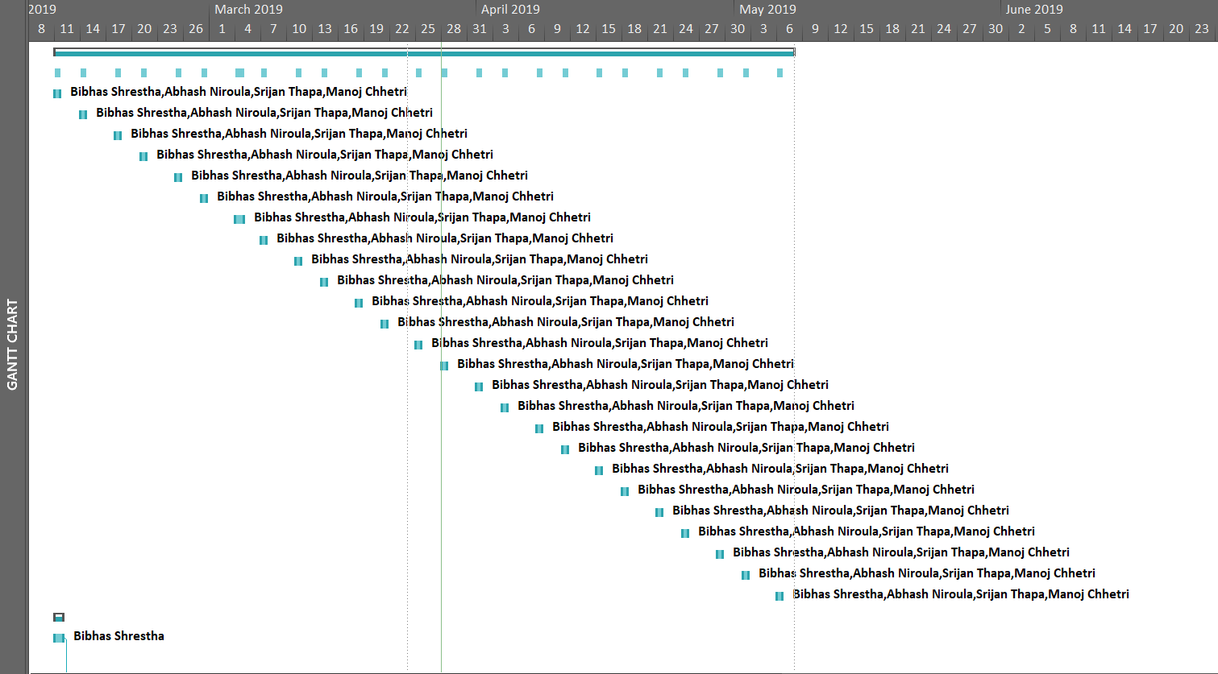

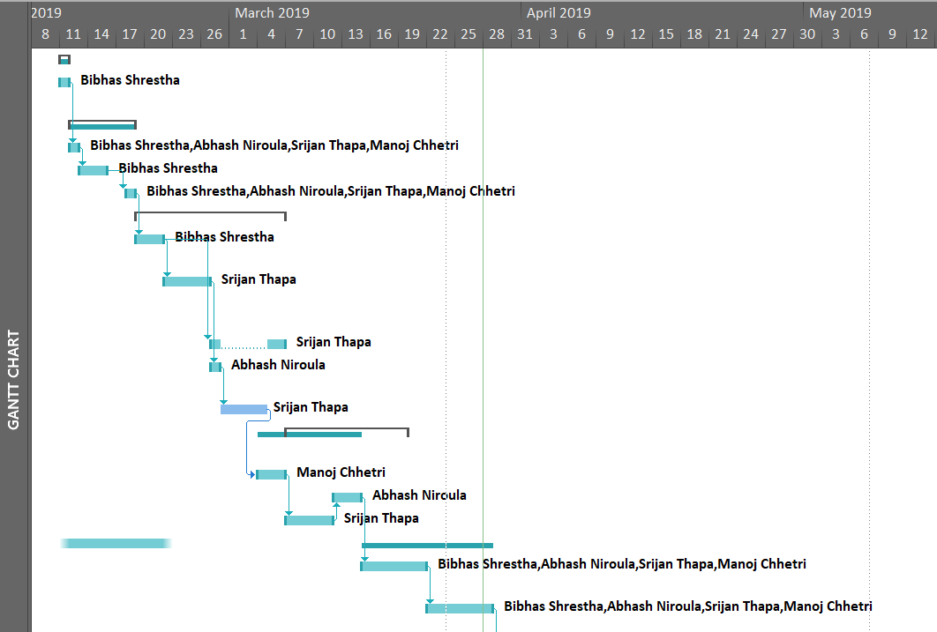

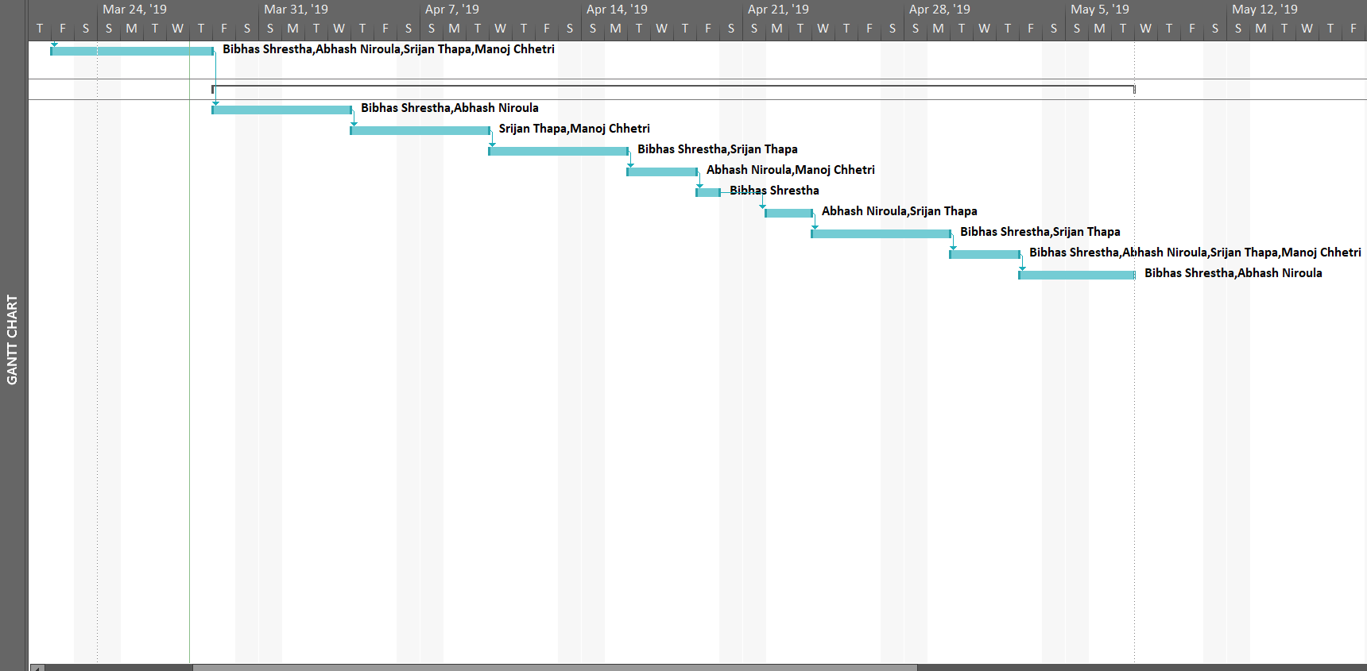

### 2.1.3 Resource Sheet

|  |  |  |  |  |  |  |  |  |
| --- | --- | --- | --- | --- | --- | --- | --- | --- |
| Resource Name | Type | Initials | Max. Units | Std. Rate | Ovt. Rate | Cost/Use | Accrue At | Base Calendar |
| Bibhas Shrestha | Work | B | 100% | $0.00/hr | $0.00/hr | $0.00 | Prorated | Standard |
| Abhash Niroula | Work | A | 100% | $0.00/hr | $0.00/hr | $0.00 | Prorated | Standard |
| Manoj Chhetri | Work | M | 100% | $0.00/hr | $0.00/hr | $0.00 | Prorated | Standard |
| Srijan Thapa | Work | S | 100% | $0.00/hr | $0.00/hr | $0.00 | Prorated | Standard |
| A4 Paper | Material | A |  | $0.00 |  | $0.00 | Prorated |  |
| Color Printer | Material | C |  | $0.00 |  | $0.00 | Prorated |  |
| Project Manager | Work | P | 100% | $0.00/hr | $0.00/hr | $0.00 | Prorated | Standard |
| Instructor | Work | I | 100% | $0.00/hr | $0.00/hr | $0.00 | Prorated | Standard |
| Scanner | Material | S |  | $0.00 |  | $0.00 | Prorated |  |
| Video Tutorials | Work | V | 100% | $0.00/hr | $0.00/hr | $0.00 | Prorated | Standard |
| Adobe Illustrator | Work | A | 100% | $0.00/hr | $0.00/hr | $0.00 | Prorated | Standard |
| Adobe Photoshop | Work | A | 100% | $0.00/hr | $0.00/hr | $0.00 | Prorated | Standard |
| High Quality Images | Work | H | 100% | $0.00/hr | $0.00/hr | $0.00 | Prorated | Standard |
| PayPal | Work | P | 100% | $0.00/hr | $0.00/hr | $0.00 | Prorated | Standard |
| Trello | Work | T | 100% | $0.00/hr | $0.00/hr | $0.00 | Prorated | Standard |
| Google Drive | Work | G | 100% | $0.00/hr | $0.00/hr | $0.00 | Prorated | Standard |
| Hangouts | Work | H | 100% | $0.00/hr | $0.00/hr | $0.00 | Prorated | Standard |
| MS PowerPoint | Work | M | 100% | $0.00/hr | $0.00/hr | $0.00 | Prorated | Standard |
| Microsoft Word | Work | M | 100% | $0.00/hr | $0.00/hr | $0.00 | Prorated | Standard |
| PHP | Work | P | 100% | $0.00/hr | $0.00/hr | $0.00 | Prorated | Standard |
| Laptop | Material | L |  | $0.00 |  | $0.00 | Prorated |  |
| Apex Oracle | Work | A | 100% | $0.00/hr | $0.00/hr | $0.00 | Prorated | Standard |
| Phone | Material | P |  | $0.00 |  | $0.00 | Prorated |  |
| HTML/CSS | Work | H | 100% | $0.00/hr | $0.00/hr | $0.00 | Prorated | Standard |
| The British College | Work | T | 100% | $0.00/hr | $0.00/hr | $0.00 | Prorated | Standard |
| Leeds Beckett University | Work | L | 100% | $0.00/hr | $0.00/hr | $0.00 | Prorated | Standard |
| W3 Schools | Work | W | 100% | $0.00/hr | $0.00/hr | $0.00 | Prorated | Standard |
| Flash Drives | Material | F |  | $0.00 |  | $0.00 | Prorated |  |
| Microsoft Project | Work | M | 100% | $0.00/hr | $0.00/hr | $0.00 | Prorated | Standard |

### 2.1.4 Calendar

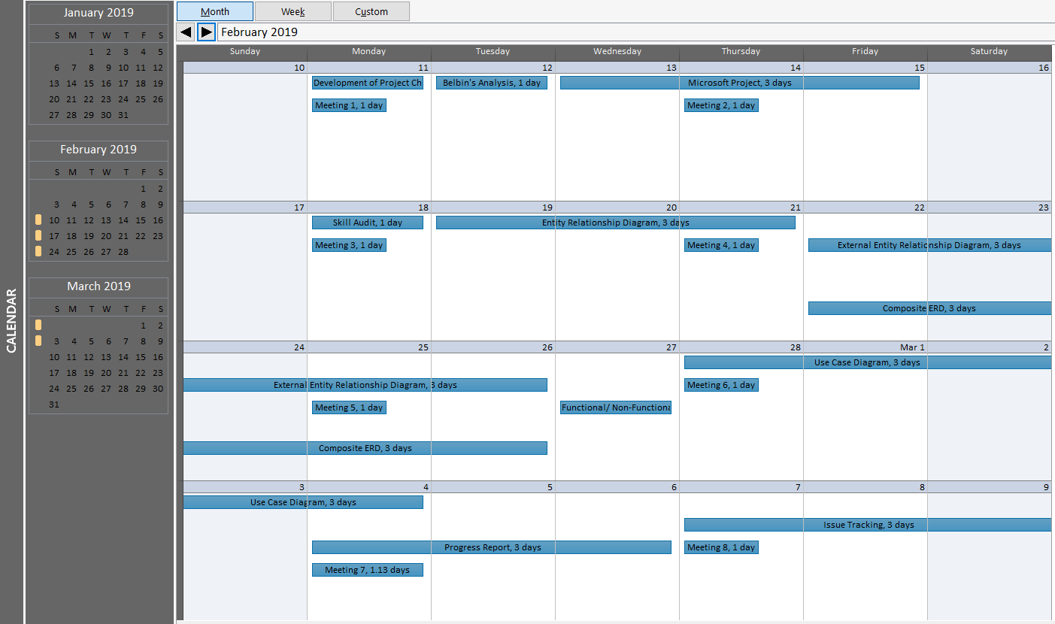

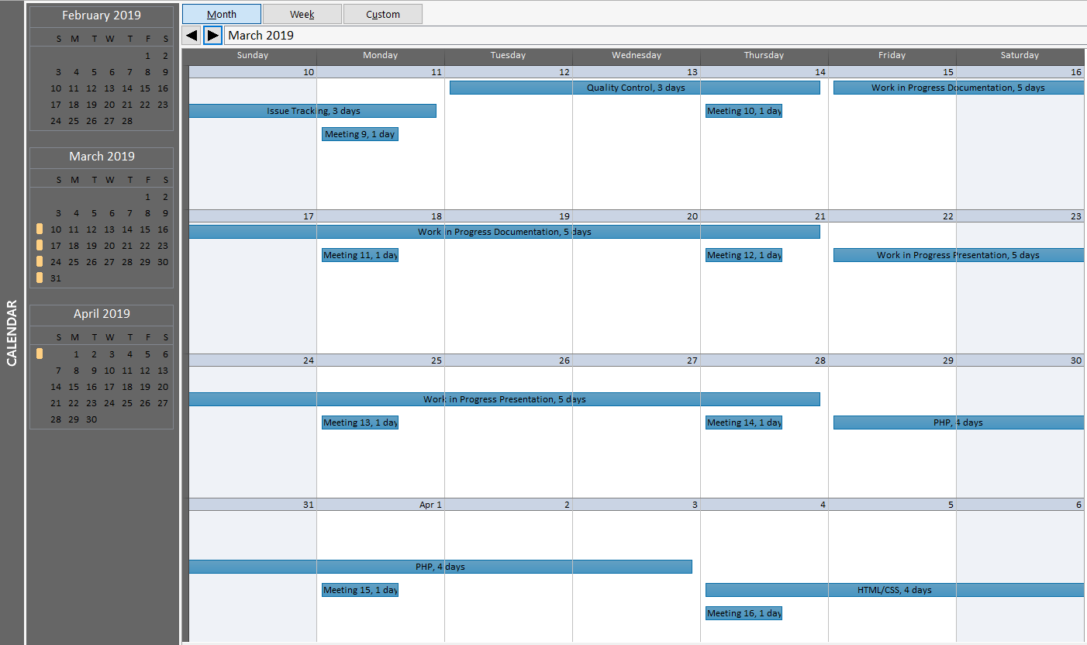

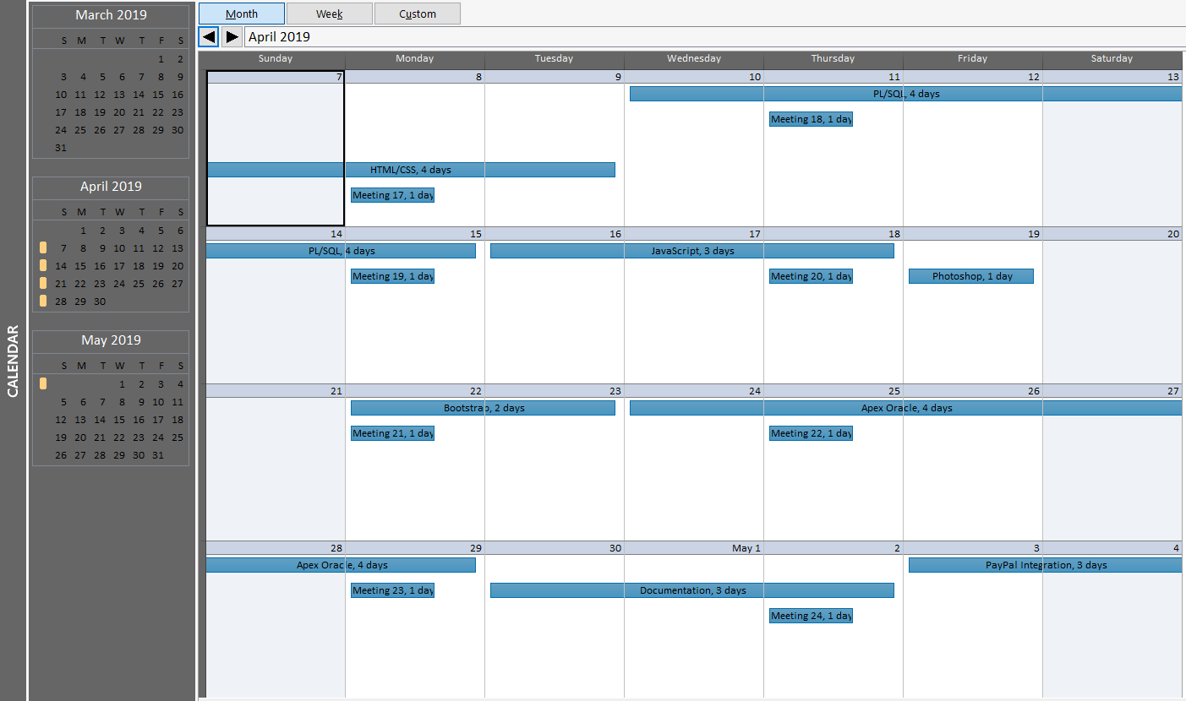

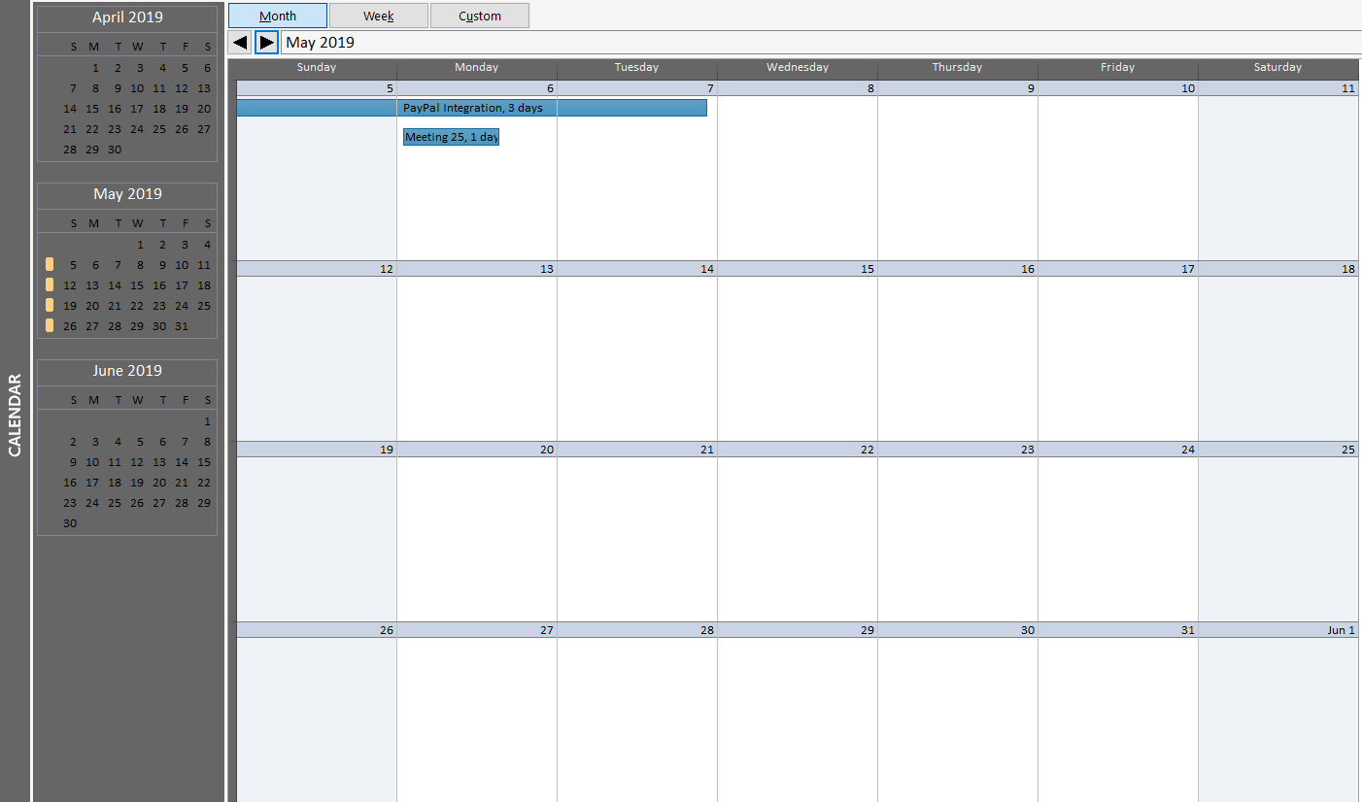

### 2.1.5 Timeline

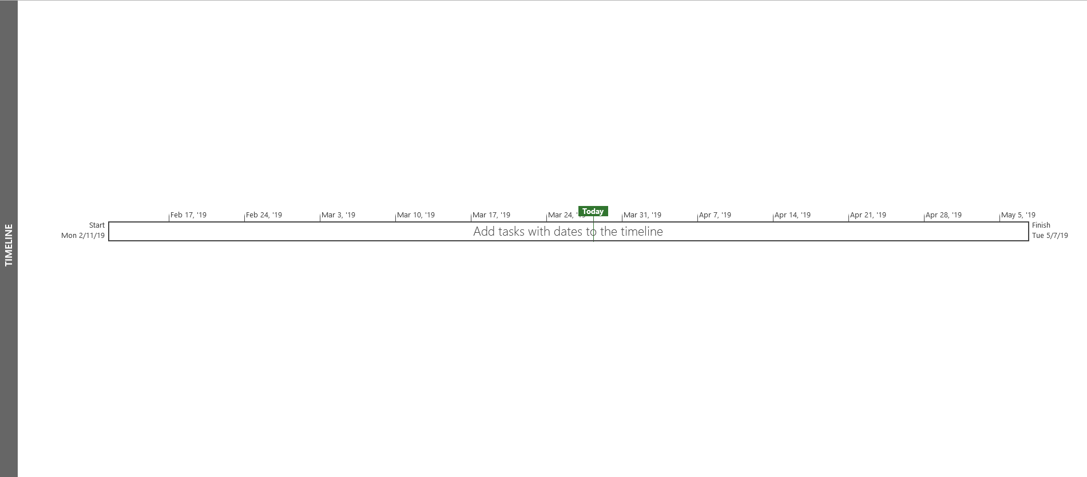

## 2.2 Communication and Collaboration Tools Used

### 2.2.1 Trello

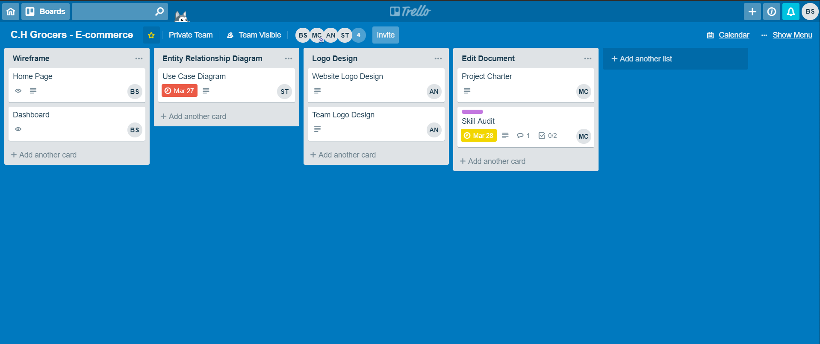

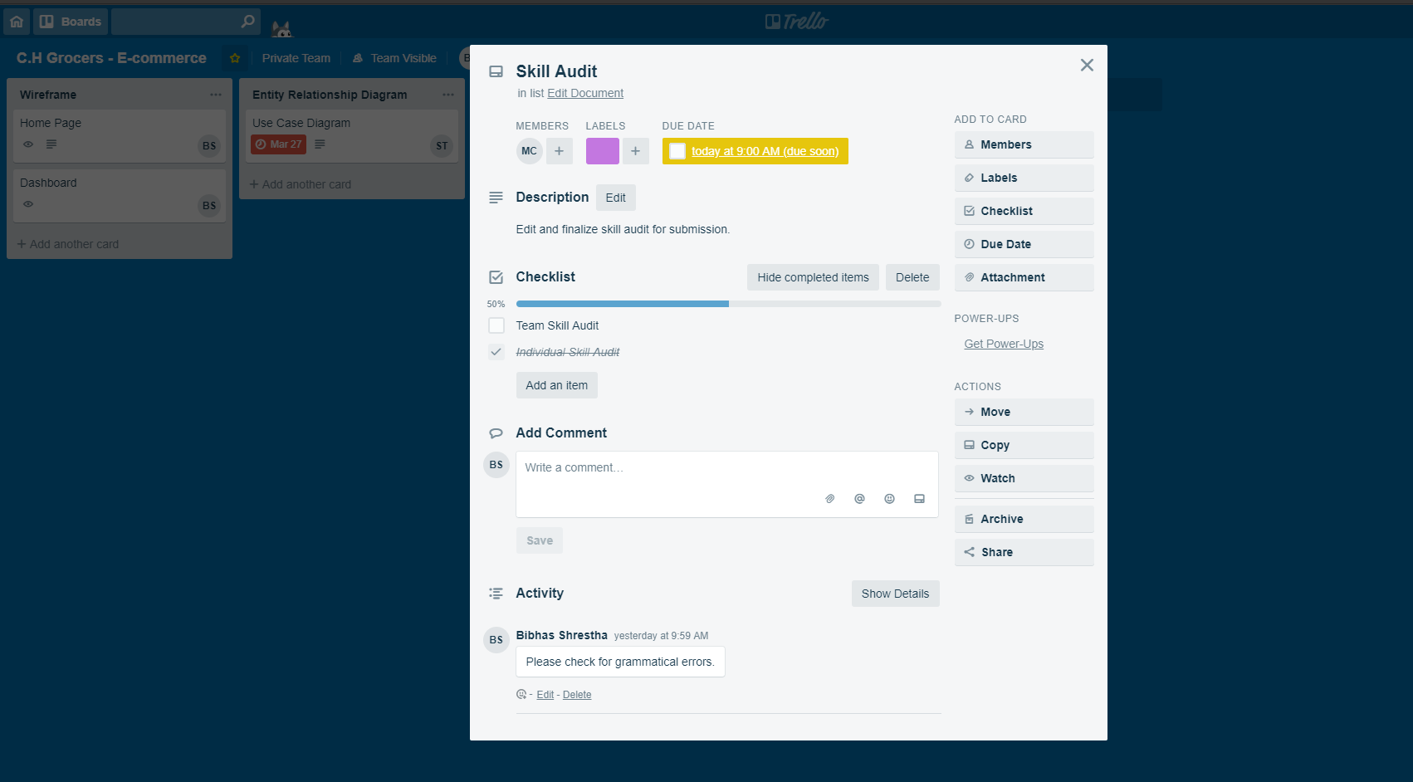

### 2.2.2 Hangouts

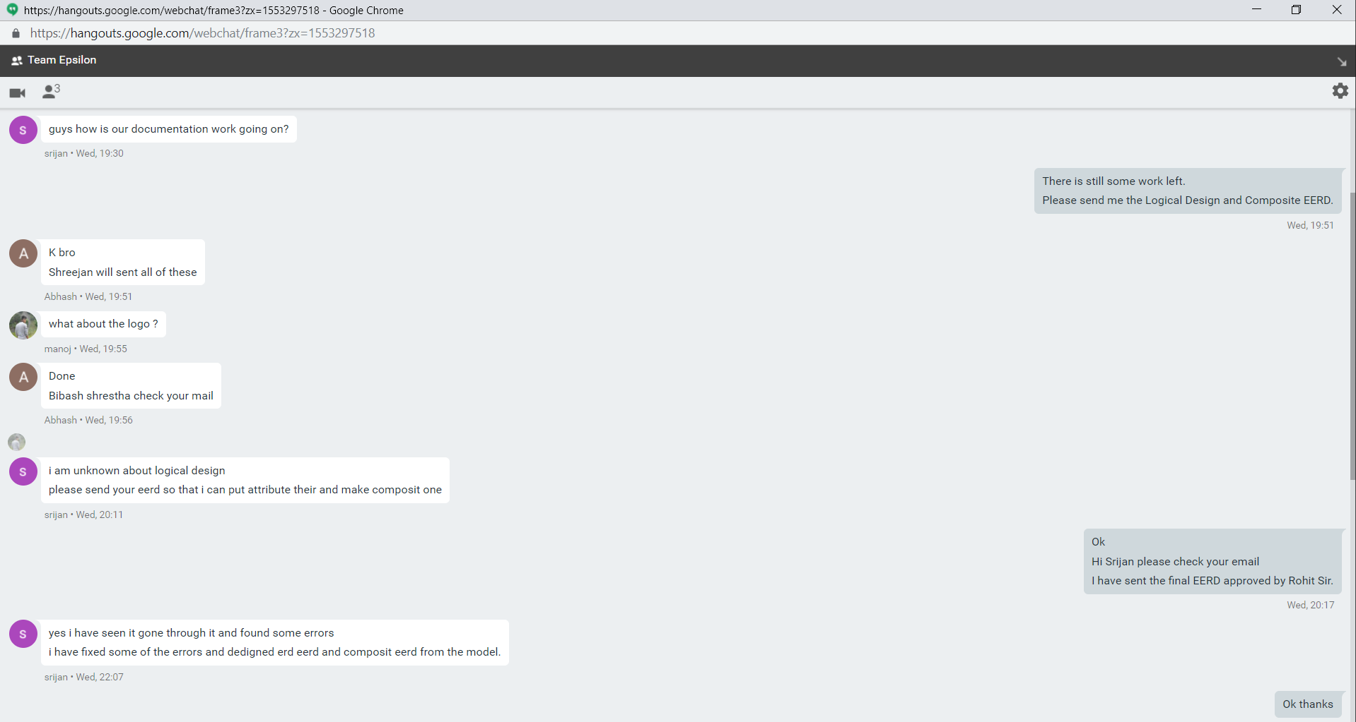

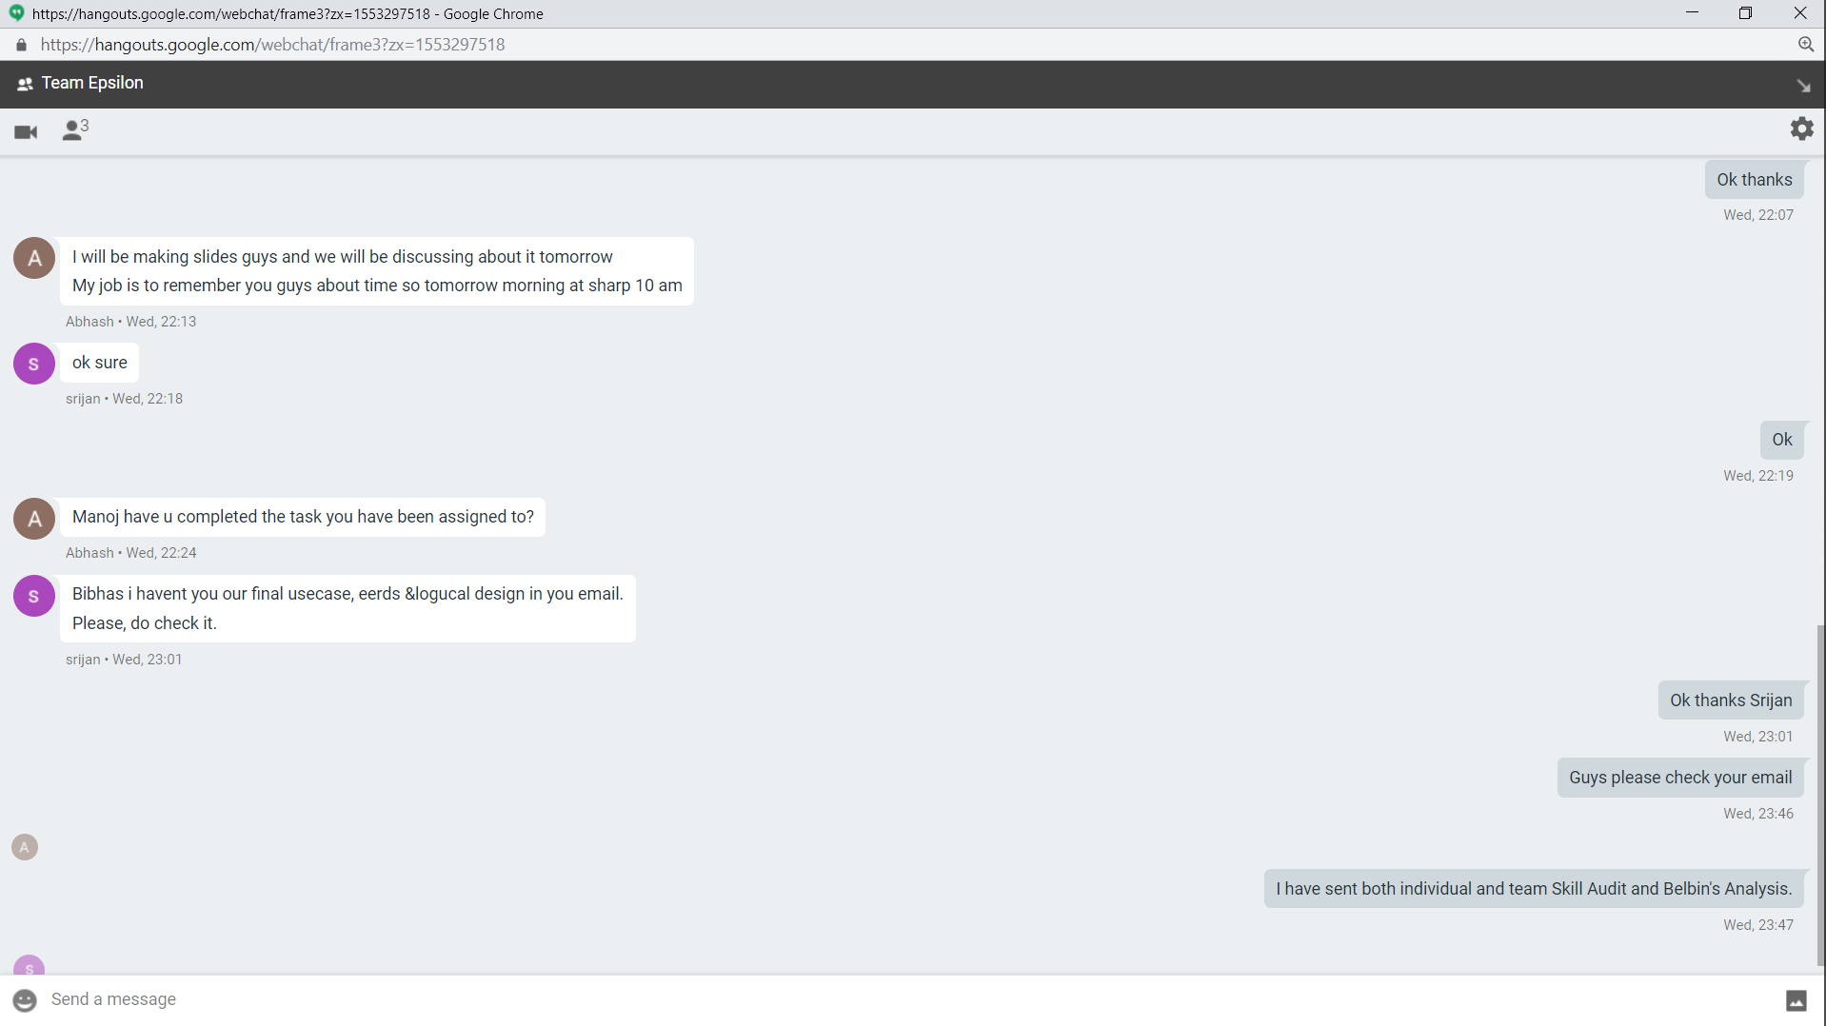

### 2.2.3 Google Drive

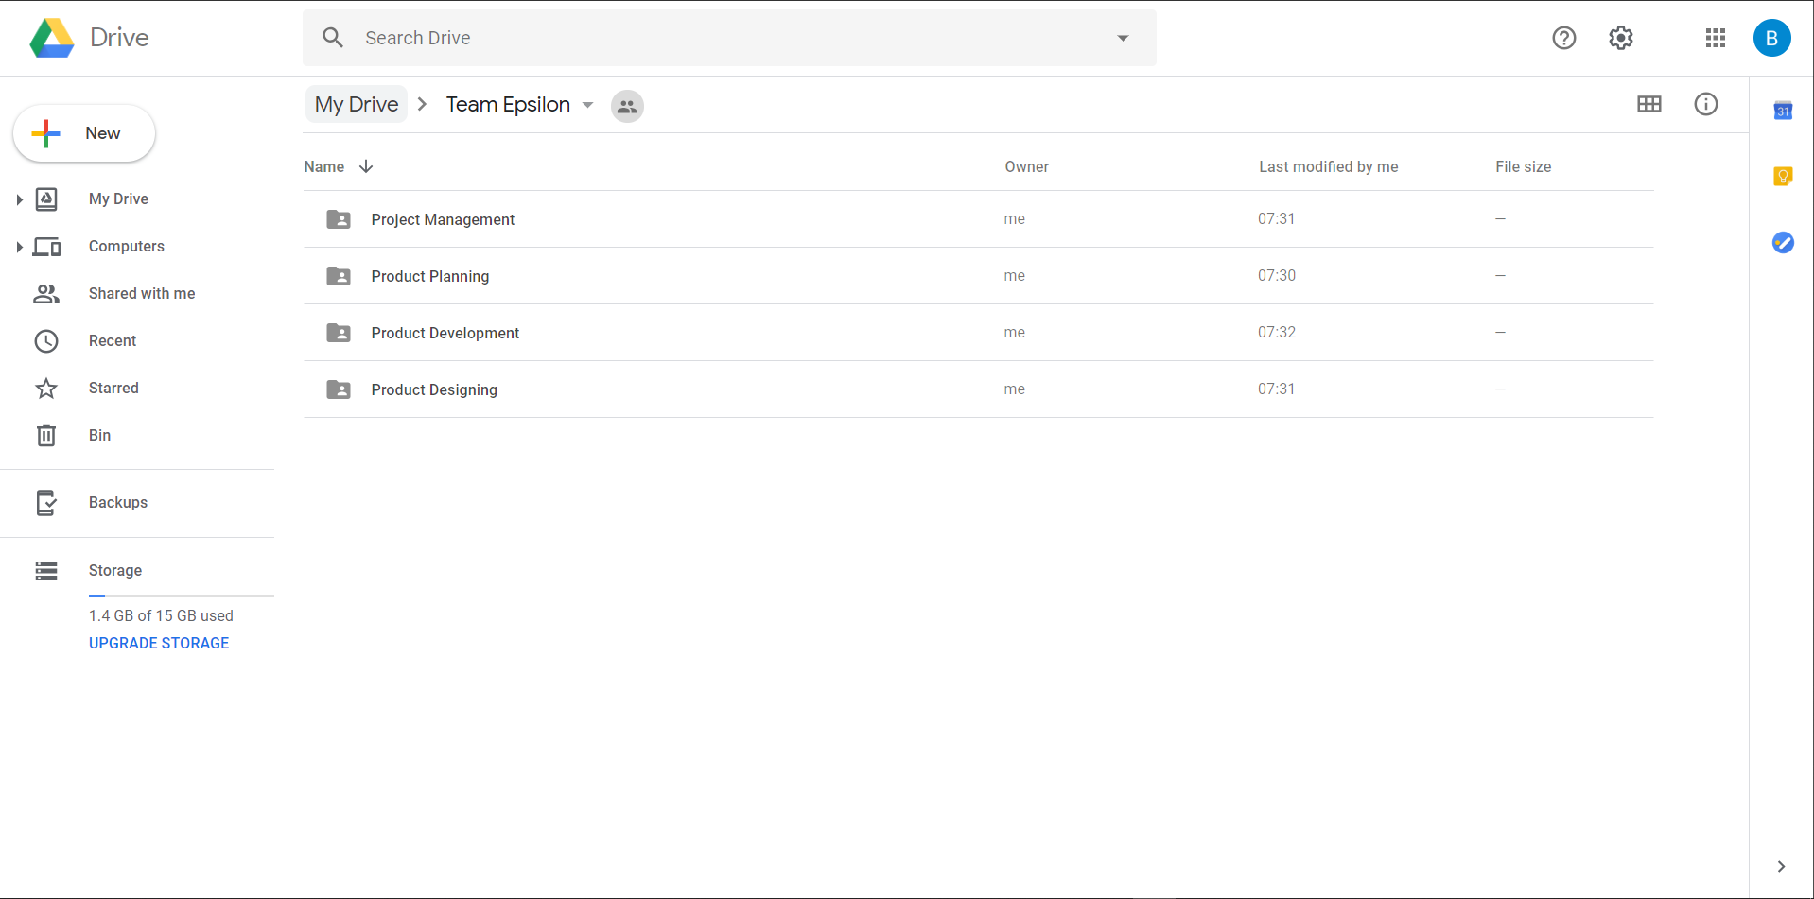

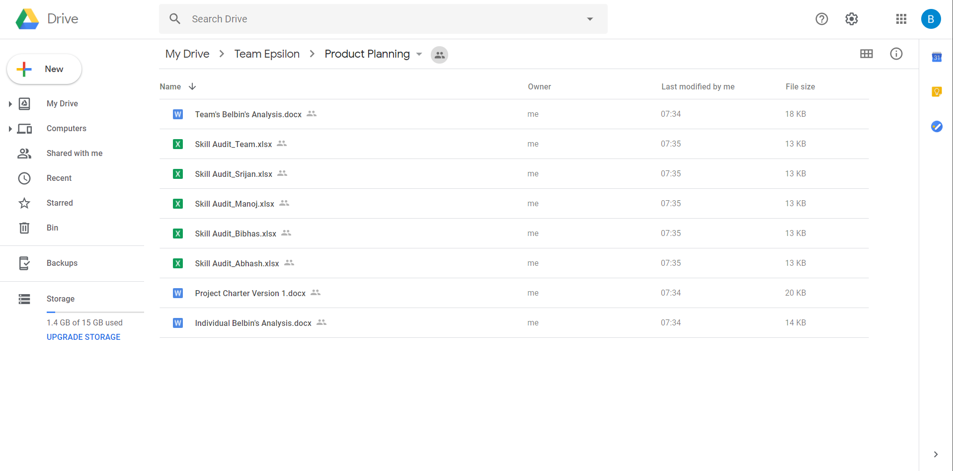

# 3. Product Designing

## 3.1 Entity Relationship Diagram



### 3.1.1 Extended Entity Relationship Diagram



### 3.1.2 Logical Design

1. User (**USER_ID**, USER_NAME, USER_DOB)
2. Trader (**USER_ID**, TRADER_NAME, TRADER_ADDRESS, TRADER_PHONE, TRADER_EMAIL)
3. Management (**USER_ID**, MANAGEMENT _NAME, MANAGEMENT _ADDRESS, MANAGEMENT _PHONE, MANAGEMENT _EMAIL)
4. Customer (**USER_ID**, CUSTOMER_NAME, CUSTOMER _ADDRESS, CUSTOMER _PHONE, CUSTOMER _EMAIL)
5. Shop (**SHOP_ID**, SHOP_NAME, SHOP _ADDRESS, SHOP _PHONE, SHOP _EMAIL, *USER_ID*)
6. Product_Type (**PRODUCT_TYPE_ID**, PRODUCT_TYPE_NAME)
7. Product_Offer (**PRODUCT_OFFER_ID**, PRODUCT_OFFER_AMOUNT)
8. Product (**PRODUCT_ID**, PRODUCT_NAME, PRODUCT_PRICE, *SHOP_ID, PRODUCT_TYPE_ID, PRODUCT_OFFER_ID*)
9. Cart (**CART_ID**, CART_NAME, *PRODUCT_ID*)
10. Order_Details (**ORDER_ID**, ORDER_DATE, ORDER_NAME, *USER_ID*)
11. Collection_Slot (**COLLECTION_SLOT_ID**, COLLECTION_SLOT_NAME, *ORDER_ID*)
12. Product_Order (**PRODUCT_ORDER_ID**, PRODUCT_ORDER_NAME)
13. Payment (**PAYMENT_ID**, PAYMENT_AMOUNT, *CART_ID, ORDER_ID, PRODUCT_ORDER_ID*)

### 3.1.3 Composite ERD



## 3.2 Use Case Diagram

### 3.2.1 Overview Use Case Diagram



### 3.2.2 Customer User Case Diagram



### 3.2.3 Trader Use Case Diagram



### 3.2.4 Management Use Case Diagram



### 3.2.5 User Use Case Diagram



## 3.3 Requirement Catalogue

### 3.3.1 Functional Requirements

#### Part A: Customer

| Requirement ID | Description | MoSCoW |
| --- | --- | --- |
| A1 | **An interface to allow customers to view items** |  |
| A1-01 | Customers should be able to navigate to products by shop or by product type. | M |
| A1-02 | Customers will be able to display items by category. | M |
| A1-03 | Customers will be able to search for items by open text search. | M |
| A1-04 | Customers will be able to sort items displayed appropriately e.g. alphabetical, date, price etc. | S |
| A1-05 | Customers will be able to sort/search items based on multiple search criteria | S |
| A2 | **Cart functionality for Customers** |  |
| A2-01 | Customers should be provided with a single basket that holds goods that spans all traders and requires a single payment. | M |
| A2-02 | Customers should be required to register before they can place an order and be logged in to access the basket. | M |
| A2-03 | Customers will be able to update or delete products in their cart list. | M |
| A3 | **Login and Registration Facility** |  |
| A3-01 | Customers should be able to review and update their account details. | M |
| A3-02 | Registration and account updates should be confirmed through interaction from email. | M |
| A3-03 | Customers will be provided with a form to register to the website. | M |
| A3-04 | Customers will be able to deactivate or delete their account. | M |
| A4 | **Payment system for the Customer** |  |
| A4-01 | Customers will be provided with a bill of products in their cart before checking out. | M |
| A4-02 | Customers will be provided with an invoice after the checkout is complete. | M |
| A4-03 | Customers will be provided with timeslots for the collection of products. | M |
| A4-04 | Customers will be provided with an online payment option. | M |

#### Part B: Trader

| Requirement ID | Description | MoSCoW |
| --- | --- | --- |
| B1 | **An Interface for traders** |  |
| B1-01 | Traders should be able to manage their products and information on their shops via a web interface. | M |
| B2-02 | Traders should be able to view and update the details of their account. | M |
| B2-03 | Traders will be able to deactivate their account. | M |
| B2-04 | Traders will be provided with terms of agreement and verification to create their account | M |
| B2 | **An Interface for traders to use CRUD functionality** |  |
| B2-01 | Traders will be able to add product items. | M |
| B2-02 | Products added will have a unique id and be associated to the trader. | M |
| B2-03 | Traders will be able to edit their product details. | M |
| B2-04 | Traders will be able to delete their product | M |
| B2-05 | Traders will be given the option to provide discount on their products. | S |
| B3 | **Reports and Accessibility** |  |
| B3-01 | Traders will receive invoice for their sales on the website. | M |
| B3-02 | Traders will be able to view their product rating. | C |
| B3-03 | Traders will be provided with periodic reports on orders and stock levels in their account. | S |
| B3-04 | Traders will be provided with their financial report and statement on request. | C |
| B3-05 | Traders will be able to view comments on their products. | W |
| B3-06 | Traders will be able to change their collection slot details. | W |

#### Part C: Management

| Requirement ID | Description | MoSCoW |
| --- | --- | --- |
| C1 | **Login Privilege** |  |
| C1-01 | Login will be provided for the management which will direct the to the management dashboard. | M |
| C1-02 | Management will also be able to access the website. | M |
| C2 | **Management Dashboard** |  |
| C2-01 | An active management dashboard link will be provided once an admin user has logged in. | M |
| C2-02 | The management page will display all activities of traders. | M |
| C3-03 | The management will have the facility to monitor trader activity. | S |
| C4-04 | The management will be able to block trader if the trader violates the terms of agreement. | M |
| C1-05 | The management will be able to accept or decline new trader requests. | S |
| C1-06 | The management will get the daily financial turnover report in the dashboard. | C |
| C3 | **Management Accessibility** |  |
| C3-01 | The management will be able to delete inappropriate products in the website. | M |
| C3-02 | The management will be able to deactivate customer and trader account. | M |
| C3-03 | The management will be able to provide new login credentials. | M |
| C3-04 | The management will be able to send email verification to customers and traders. | M |

#### Part D: User

| Requirement ID | Description | MoSCoW |
| --- | --- | --- |
| D1 | **Registration** |  |
| D1-01 | Registration form will be provided to new users. | M |
| D1-02 | Users will be provided with email verification before signing in on the website. | M |
| D1-03 | The user will be provided with the option to change their password through email verification in the case they forget their password. | C |
| D2 | **View items on the interface** |  |
| D2-01 | The user will be able to view items on the e-commerce platform. | M |
| D2-02 | The user will be able to sort items on the website. | M |
| D2-03 | The user will be able to search for item on the website. | M |
| D2-04 | The user will be able to categorize items on the website. | M |

### 3.3.2 Non-Functional Requirements

| Requirement ID | Description | MoSCoW |
| --- | --- | --- |
| D1 | **The website will comply with the following non-functional requirements.** |  |
| D1-01 | HTML/CSS template will be used as suited to requirements. | M |
| D1-02 | The template will be applied consistently throughout the site. | S |
| D1-03 | Third party plugins will be used for extra functionality. | C |
| D1-04 | Laravel framework will be used to create the website. | S |
| D1-05 | JavaScript will be used for web functionality. | S |
| D1-06 | The customers will be able to view their purchase records. | W |
| D1-07 | The customers would be able to like or dislike comments on the products. | W |
| D1-08 | Product offers and advertisements would be provided to the customers via email. | W |
| D1-09 | Customers would be able to share products on their social media handles. | W |
| D1-10 | The web interface will be made responsive for use across multiple devices. | S |

## 3.4 Team Logo



### 3.4.1 Website Logo



### 3.4.2 Website Wireframe

#### Homepage

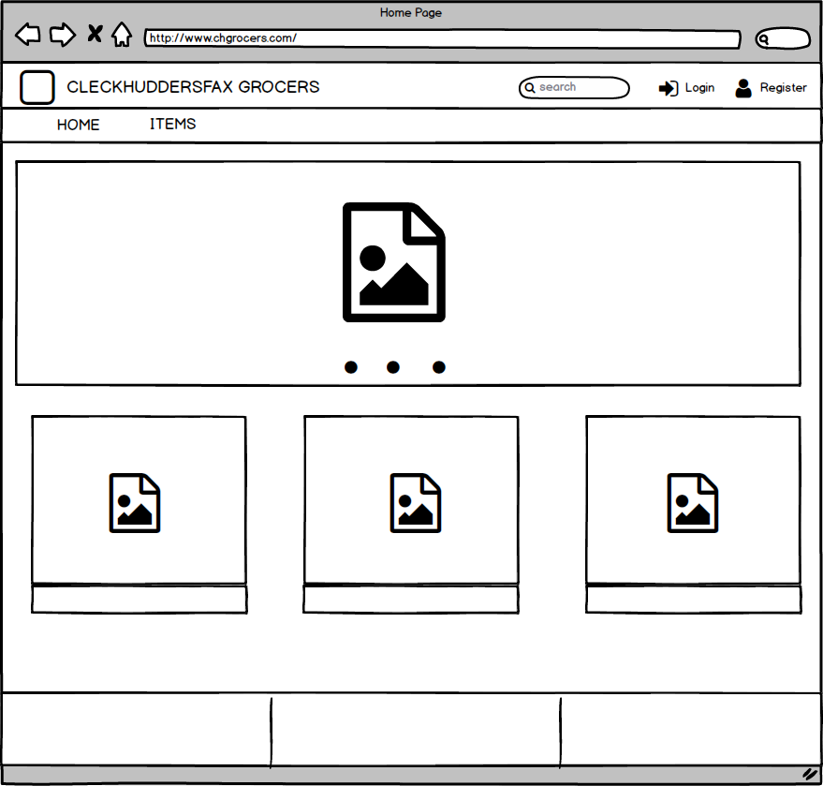

#### Login

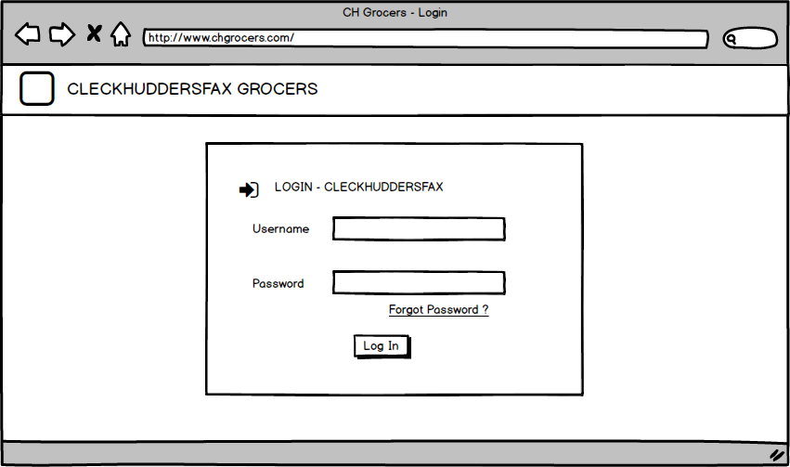

#### Trader Dashboard

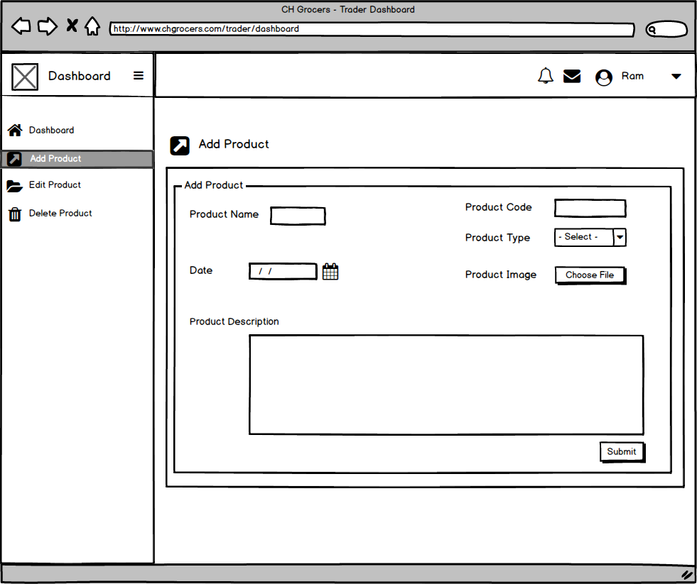

#### Management Dashboard

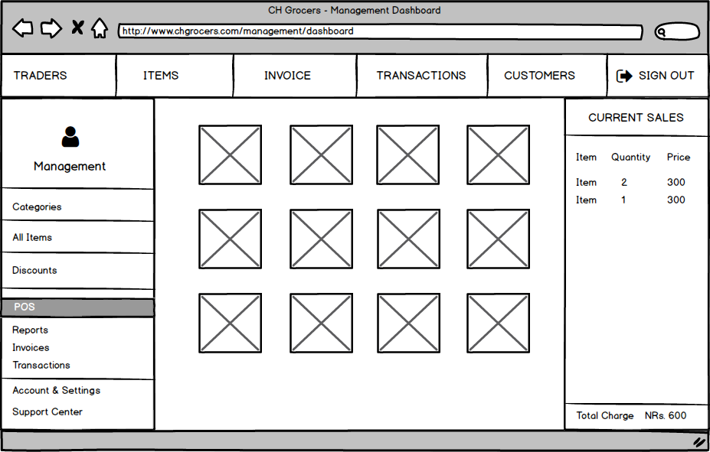

#### User Registration

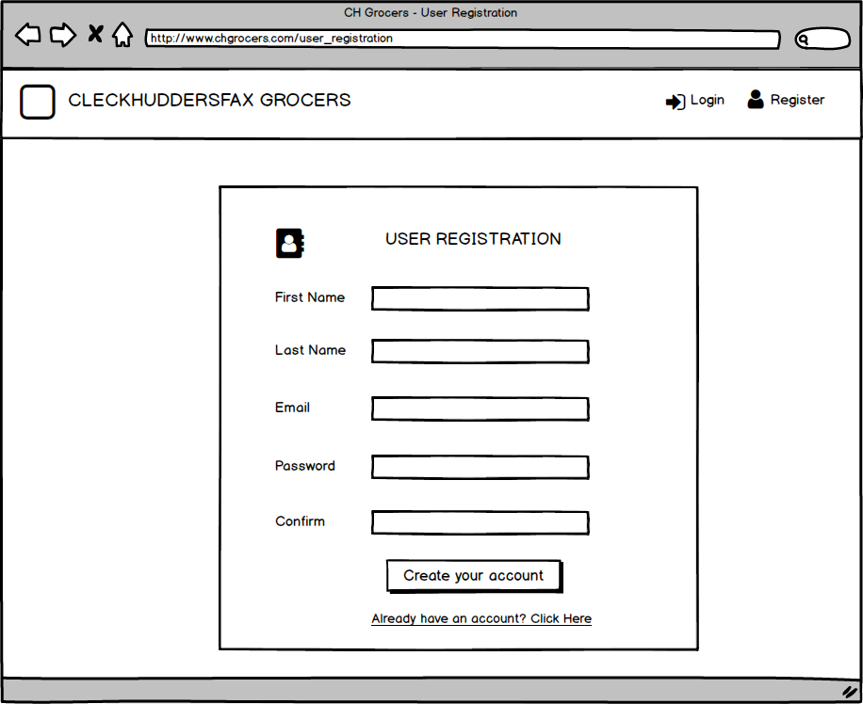

#### Trader Registration

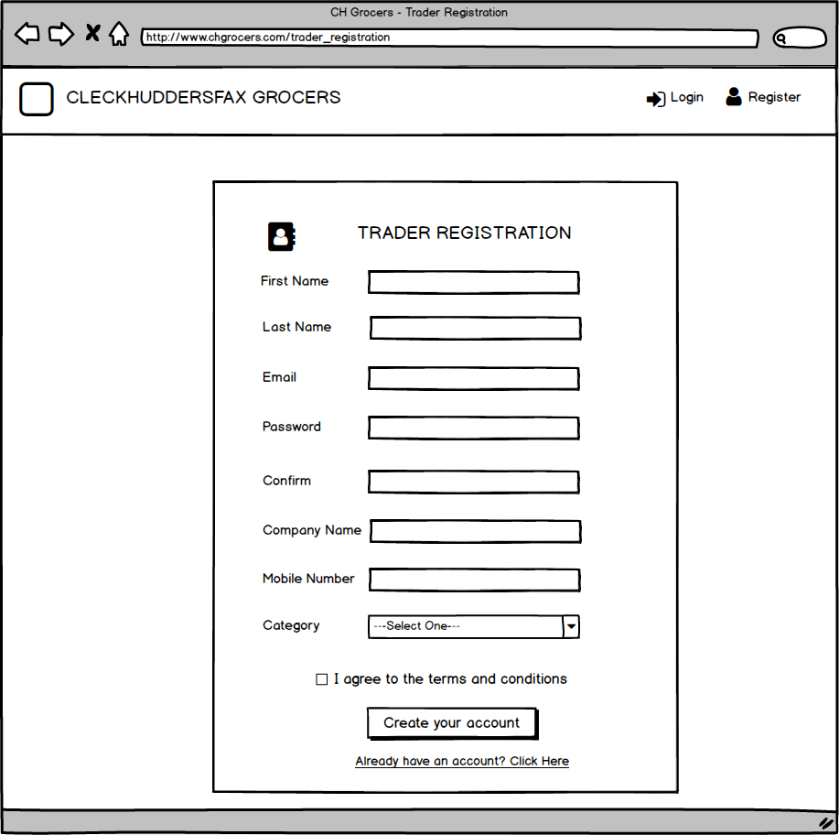

#### Account Settings and Preferences

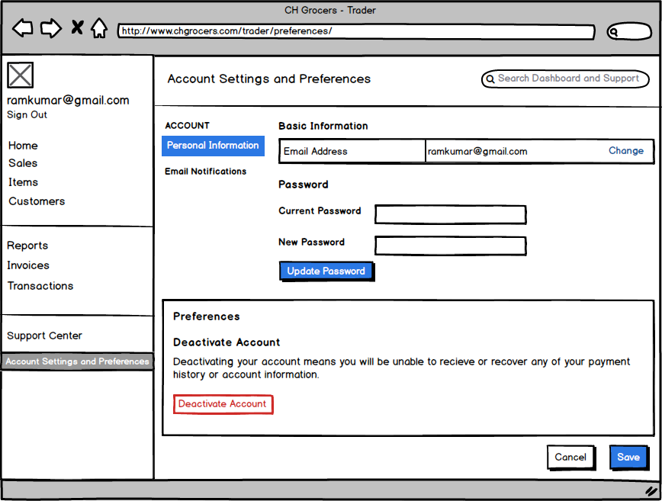

# 4. Product Development

## 4.1 Database Tables in Oracle

### 4.1.1 User

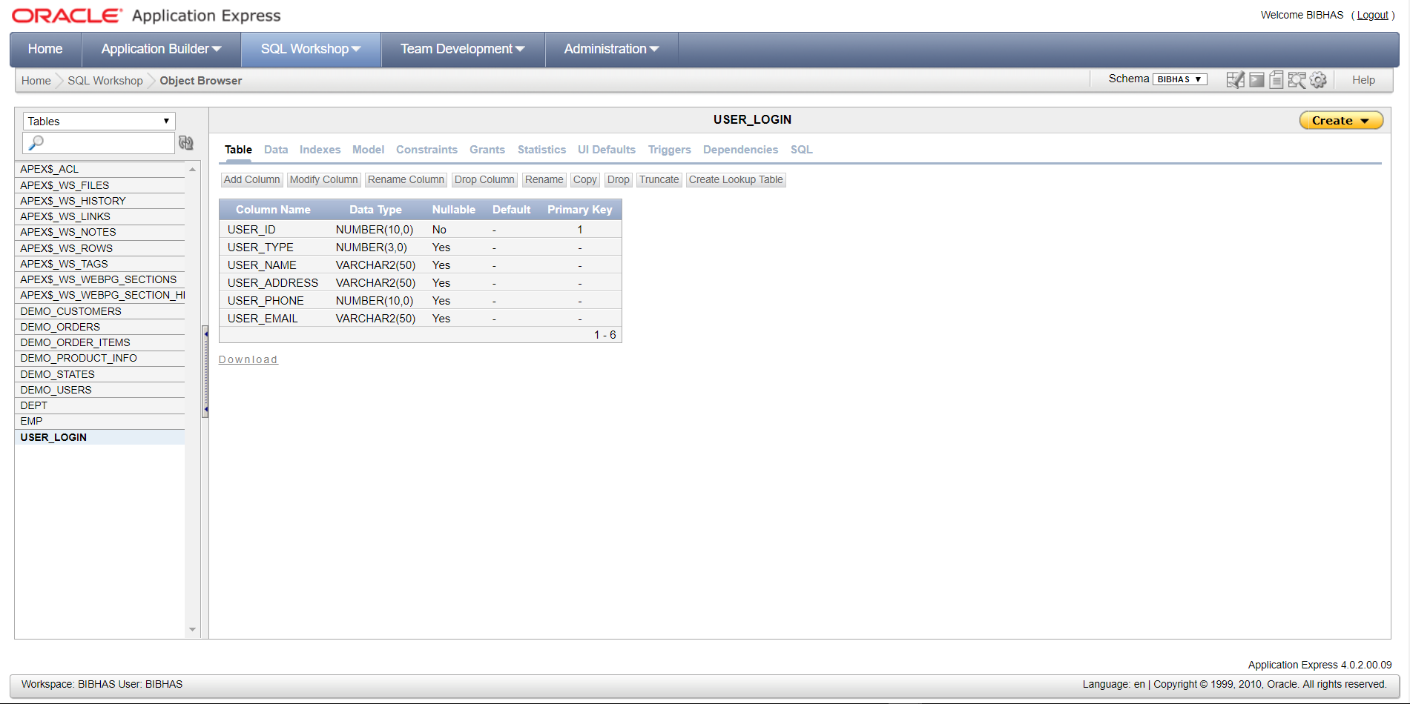

### 4.1.2 Shop

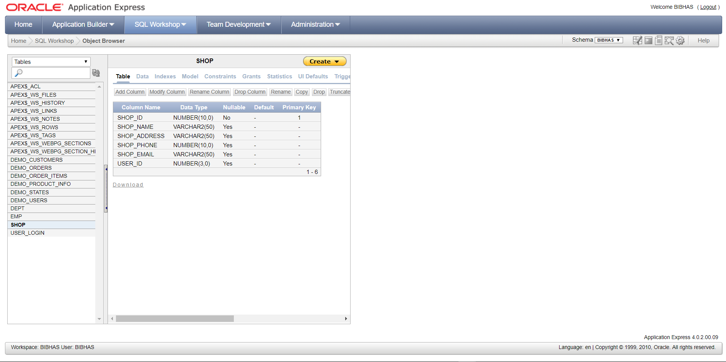

### 4.1.3 Product Types

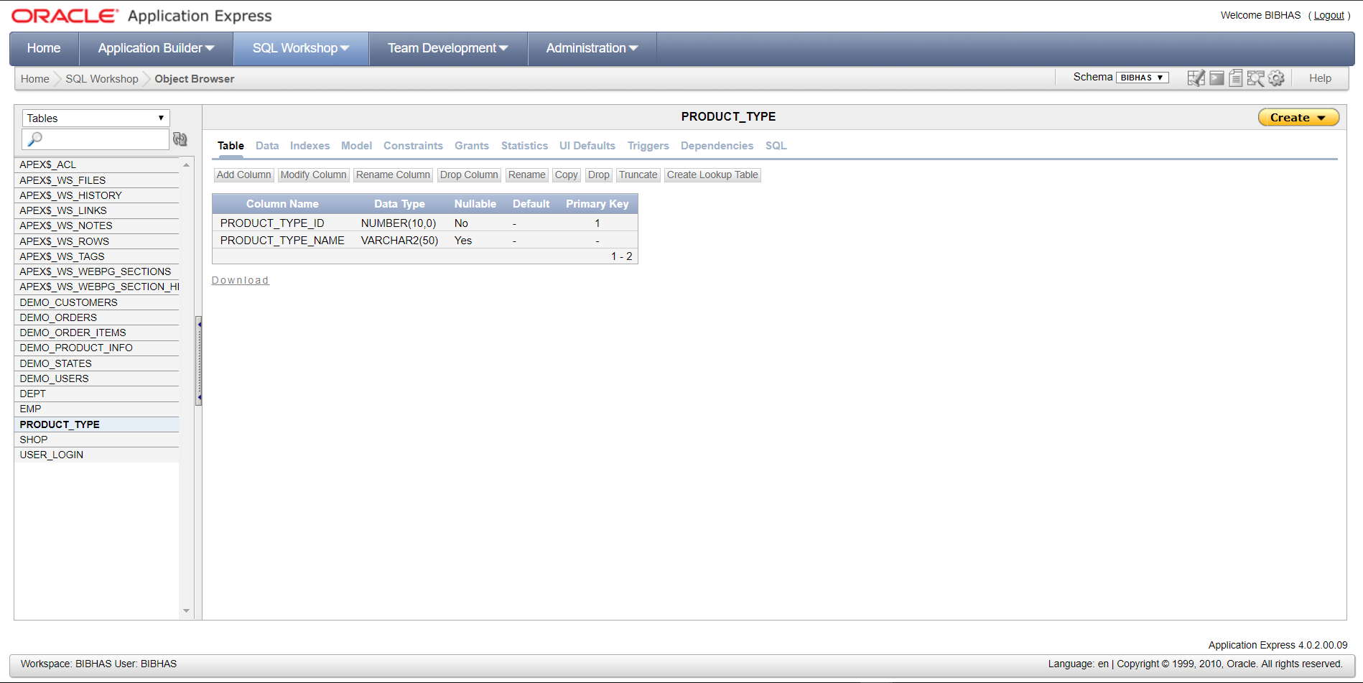

### 4.1.4 Product

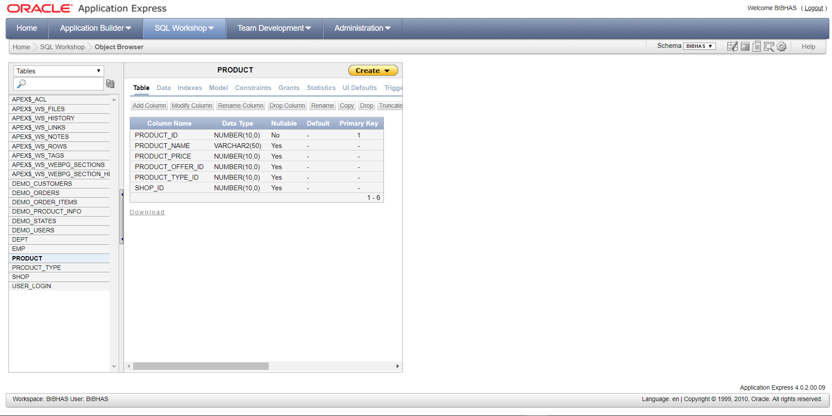

### 4.1.5 Product Offer

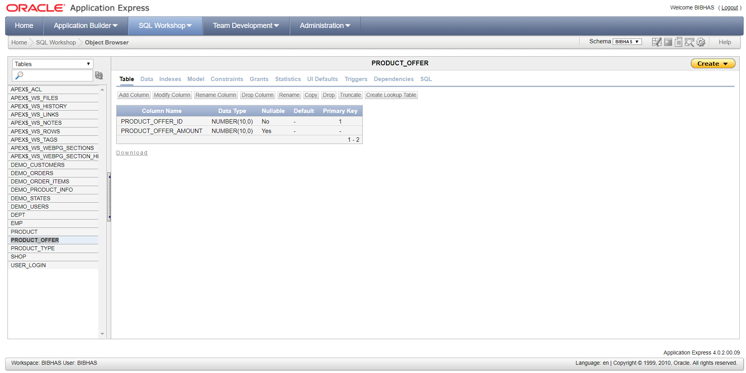

### 4.1.6 Cart

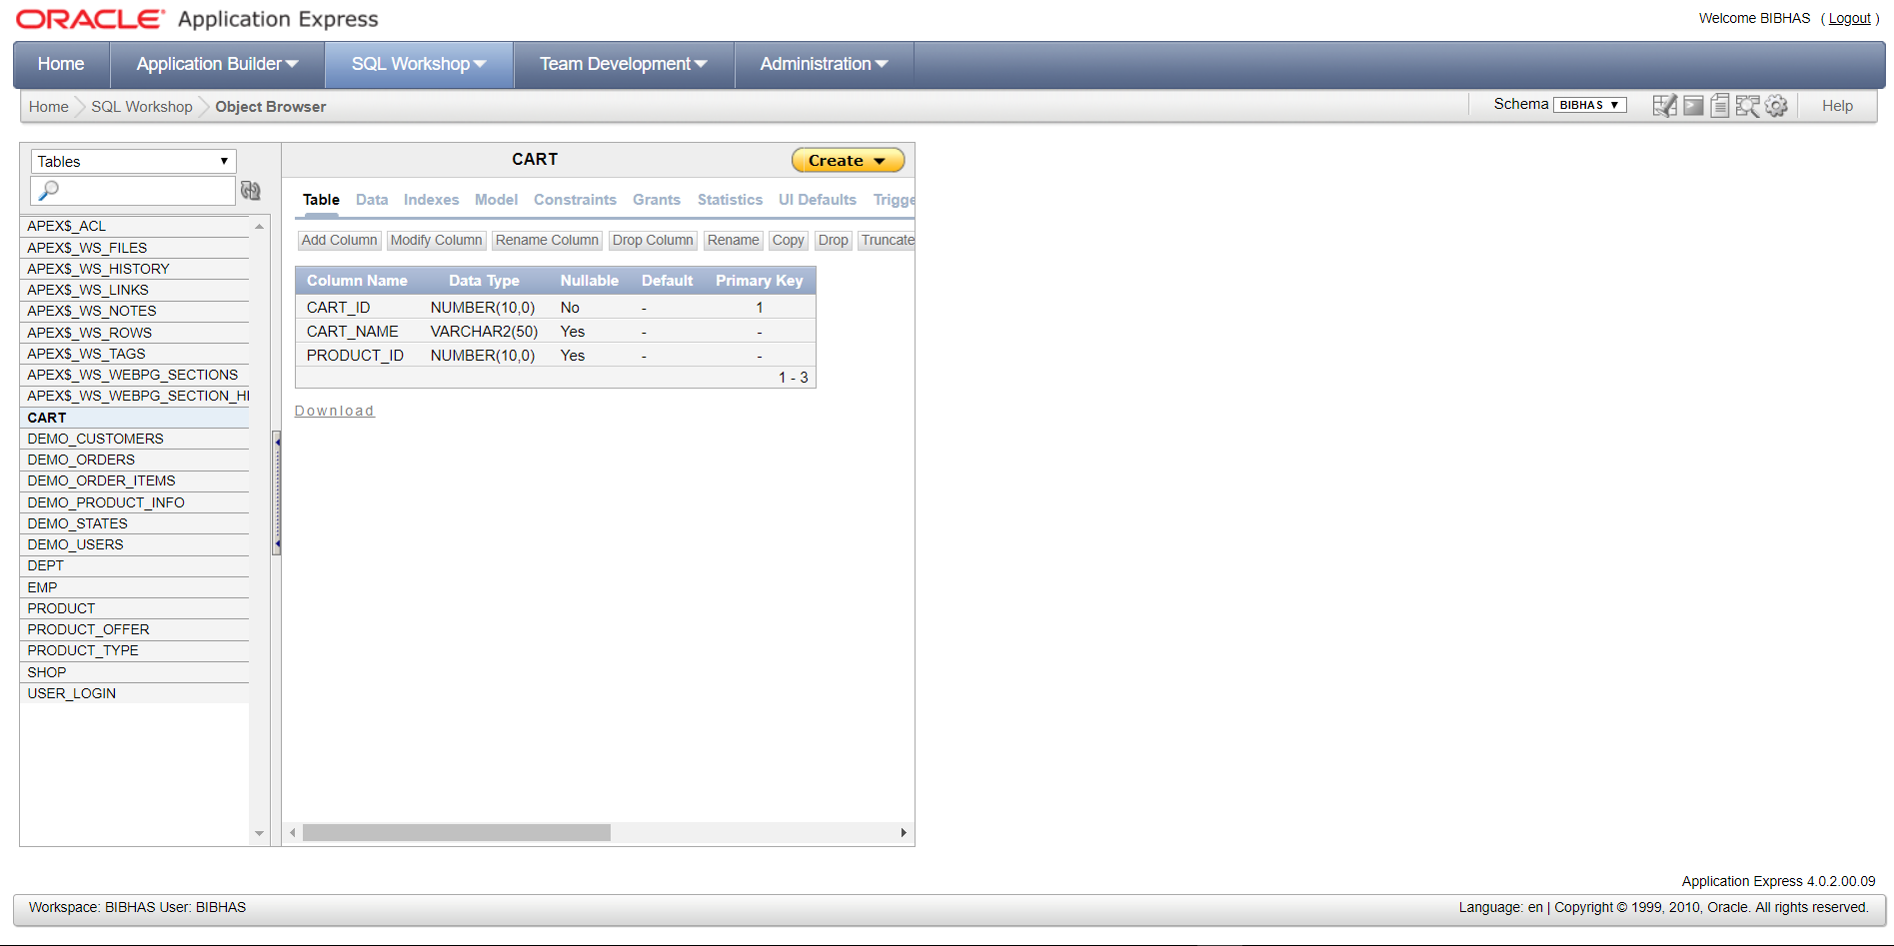

### 4.1.7 Product Order

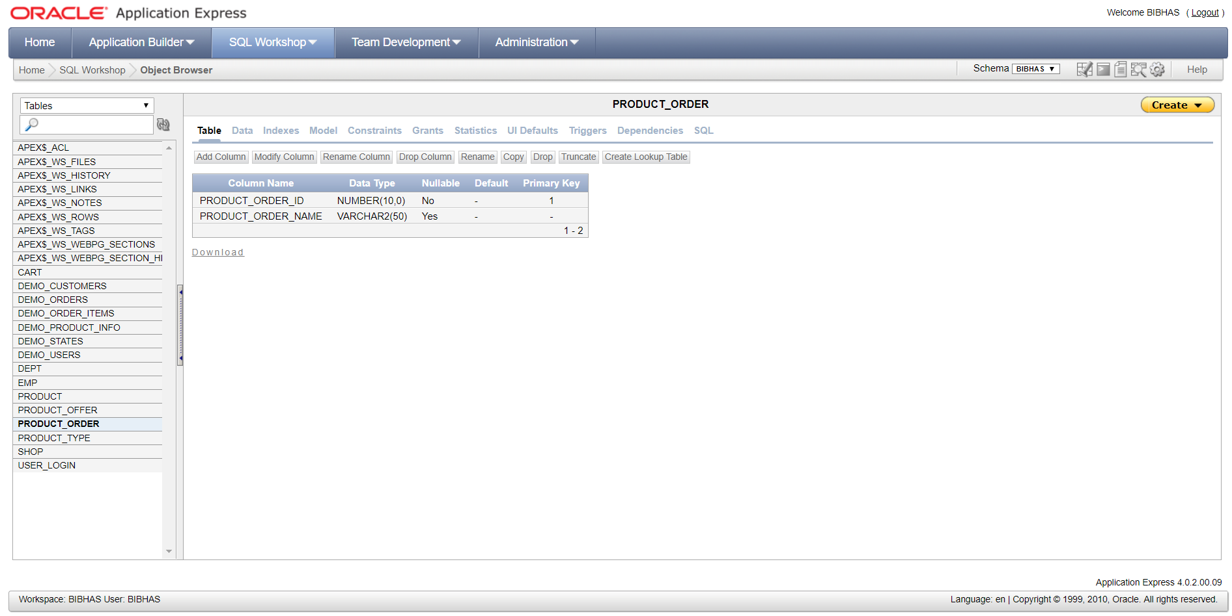

### 4.1.8 Order Detail

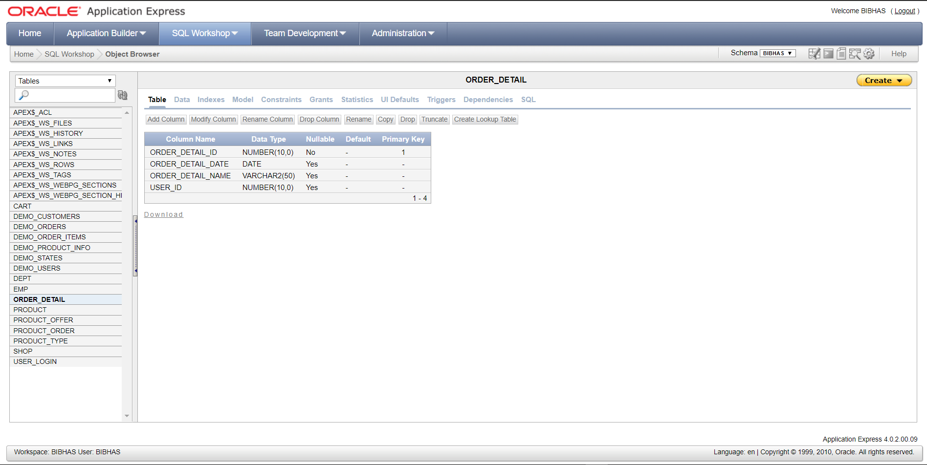

### 4.1.9 Payment

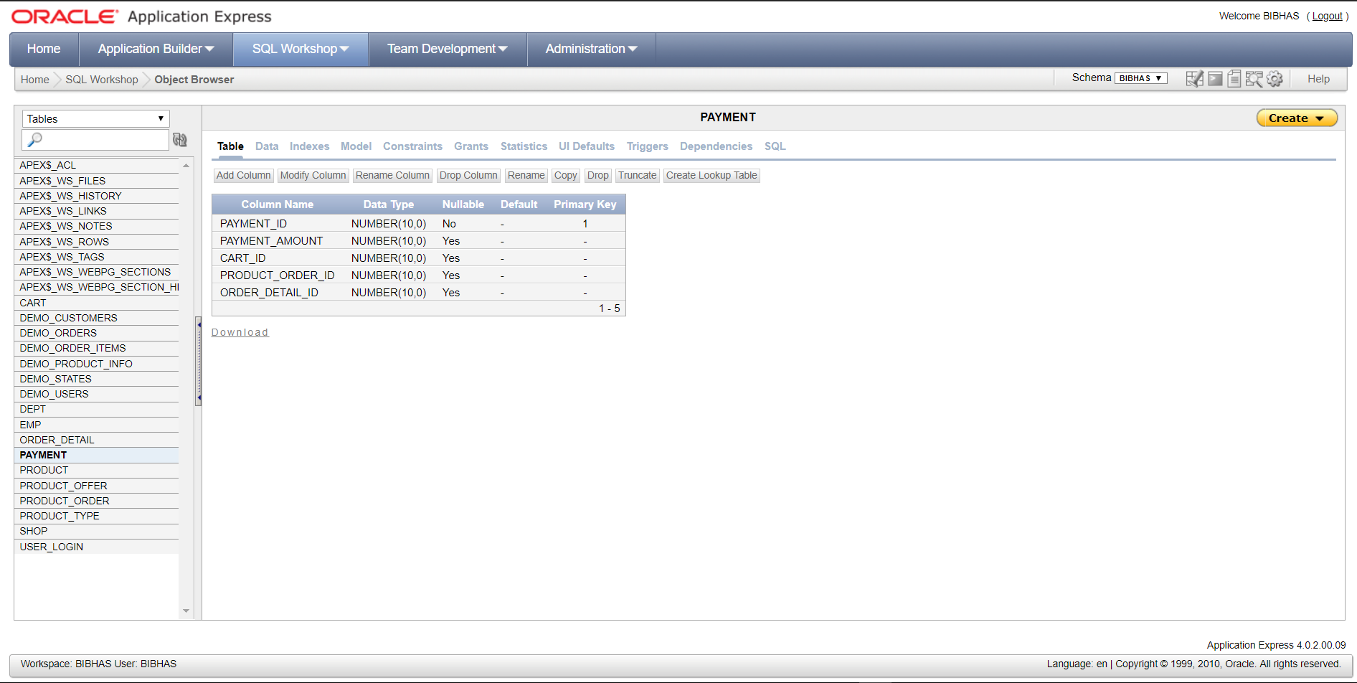

### 4.1.10 Collection Slot

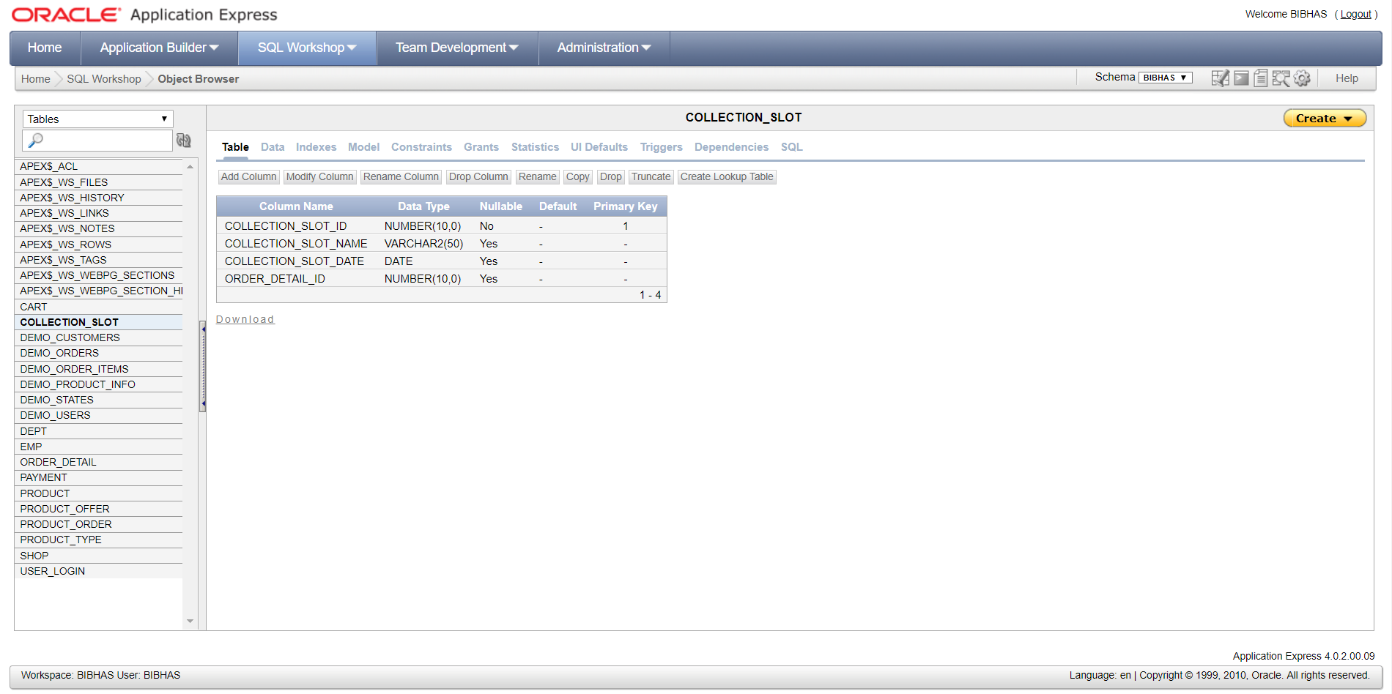

## 4.2 Website Home Page

